**ONLINE CAR QUOTATION SYSTEM**

**AHMAD AFIQ AHNAF BIN HARUDIN**

**Thesis submitted in fulfillment of the requirements of the award of the**

**Diploma of Computer Science**

**Faculty of Computer System and Software Engineering**

**UNIVERSITY MALAYSIA PAHANG**

**2017**

**ACKNOWLEDGEMENTS**

Firstly, I would like to thank God for the blessings for giving me strength and patience throughout the duration in completing this project report. I am very honoured and grateful to Dr. Salwana Binti Mohamad for being my supervisor. The advice and comment from her is a great contribution for the achievement of my project report. Without her help, it would be difficult for me to complete all the task in this project. Also, I would like to thank to my course mates who kind in sharing knowledge and time to help me with my project report. I really appreciate it.

**ABSTRACT**

This study focuses on development of online car quotation system. Online car quotation system is a system to help user support decision making for the user to select ideal cars. This online decision support system is advantageous and accessible for user and admin. By developing this system, it can reduce time for user to find information about car models and specifications. The user can easily find information about car models and specifications. Next, admin will be able to get user details and their question and feedback. Also, admin can reply user question and feedback. This system will be developed using system development life cycle (SDLC) methodology.

**TABLE OF CONTENT**

|  |  |
| --- | --- |
|  | **Page** |
| **TITLE OF PROJECT** |  |
| **ACKNOWLEDGEMENTS** |  |
| **ABSTRACT** |  |
| **TABLE OF CONTENT** |  |

|  |  |  |
| --- | --- | --- |
| **SECTION** | **TITLE** | **PAGE** |
| **1** | **CHAPTER 1: INTRODUCTION** |  |
| 1.1 | Background of Study | 1 |
| 1.2 | Problem Statement | 1 |
| 1.3 | Aim and Objectives | 2 |
| 1.4 | Scope of project | 2 |
| 1.5 | Significance of the project | 2 |
| 1.6 | Conclusion | 3 |
| **2** | **CHAPTER 2: REVIEW OF EXISTING SYSTEMS** |  |
| 2.1 | Existing System | 4 |
| 2.1.1 | Audi.com | 4 |
| 2.1.2 | Nissan-Global.com | 5 |
| 2.1.3 | Proton-Edar.com | 6 |
| 2.2 | Comparison of Existing System | 7 |
| 2.3 | Software Development | 8 |
| 2.4 | Strengths and Weaknesses | 9 |
| 2.4.1 | Audi.com | 9 |
| 2.4.2 | Nissan-Global.com | 9 |
| 2.4.3 | Proton-Edar.com | 10 |
| 2.5 | Conclusion | 10 |
| **3** | **CHAPTER 3: METHODOLOGY** |  |
| 3.1 | System Development Life Cycle (SDLC) | 11 |
| 3.2 | Planning Phase | 12 |
| 3.2.1 | User Requirement | 12 |
| 3.2.2 | System Requirement | 13 |
| 3.2.2.1 | Hardware Requirement | 13 |
| 3.2.2.2 | Software Requirement | 12 |
| 3.2 | System Requirement | 13 |
| 3.2.1 | Hardware Requirement | 13 |
| 3.2.2 | Software Requirement | 13 |
| 3.3 | Analysis Phase | 14 |
| 3.3.1 | Flowchart | 14 |
| 3.3.2 | Context Diagram | 25 |
| 3.3.2 | Level 0 Data Flow Diagram | 26 |
| 3.3.3 | Level 1 Data Flow Diagram for Ask Question process | 27 |
| 3.3.4 | Level 1 Data Flow Diagram for Answer Question process | 28 |
| 3.3.5 | Level 1 Data Flow Diagram for Give Feedback process | 29 |
| 3.3.6 | Level 1 Data Flow Diagram for Comment Feedback process | 30 |
| 3.4 | Design Phase | 31 |
| 3.4.1 | Database Design | 31 |
| 3.4.1.1 | Entity Relation Data Diagram | 31 |
| 3.4.1.2 | Data Dictionary | 32 |
| 3.4.2 | User Interface Design | 39 |
| 3.5 | Implementation Phase | 49 |
| 3.5.1 | User Acceptance Test (UAT) | 49 |
| 3.5.1.1 | User Acceptance Test for User | 50 |
| 3.5.1.2 | User Acceptance Test for Admin | 51 |
| 3.6 | Maintenance Phase | 52 |
| 3.7 | Gantt Chart | 52 |
| 3.8 | Conclusion | 53 |

|  |  |  |
| --- | --- | --- |
| **4** | **CHAPTER 4: IMPLEMENTATION AND TESTING** |  |
| 4.1 | Introduction | 54 |
| 4.2 | Implementation Process | 54 |
| 4.3 | User Manual | 55 |
| 4.3.1 | Admin | 55 |
| 4.3.2 | User | 60 |
| 4.4 | Implementation Of Database | 65 |
| 4.5 | User Acceptance Test (UAT) | 70 |
| 4.5.1 | User Acceptance Test for User | 71 |
| 4.5.2 | User Acceptance Test for Admin | 72 |
| 4.6 | Conclusion | 73 |

|  |  |  |
| --- | --- | --- |
| **5** | **CHAPTER 5: CONCLUSION** |  |
| 5.1 | Introduction | 74 |
| 5.2 | System Constraint | 74 |
| 5.3 | System Improvement | 75 |

**REFERENCES** 76

|  |  |
| --- | --- |
| **APPENDICES** | 77 |

**CHAPTER 1**

**INTRODUCTION**

* 1. **BACKGROUND OF STUDY**

In this modern era, the internet has been widely used in daily life. The internet contains a lot of system that provide much information according to user requirement. There are some people who prefer to go directly to car dealer. There are also some people who prefer to surf online website on the internet.

There is some existing system on the website such as Proton, Toyota, Nissan, and BMW. Those websites give information about the cars and specifications which can easily view by the user. This website also can help the user to find the suitable cars based on their budget and car price. The website also consists of the company information, address of the company and the company contact number.

Thus, the Online Car Quotation System is proposed to support decision making for the user by calculating payment loan, viewing and giving user feedback, and finding suitable car models based on car price range and the branches’ location. The user also can ask any question related with this company or by giving feedback about car models.

**1.2 PROBLEM STATEMENT**

1. They are having problem to find the branches and also take a long time to arrive the company branches.
2. The user only gets less information about the car if the user go directly to car dealer.
   1. **AIM AND OBJECTIVES**
3. **Aim:**

To purpose an online system that support decision making for the user to select ideal cars.

1. **Objectives:**
2. To design the database and GUI for Online Car Quotation System.
3. To develop a system that give the user an information to decide an ideal car for them.
4. To verify bugs of the Online Car Quotation System.
   1. **SCOPE OF PROJECT**
5. The system only serves local car brands placed around states in Malaysia.
6. The system focus only for the public user who are having problem to find ideal cars for their own use.
7. This system include two local brands only which are Proton and Perodua.
   1. **SIGNIFICANCE OF THE PROJECT**
8. The system can reduce time taken for the user finding the information about the cars.
9. The system also can improve the performance of others website that related to this project task.
10. The system will increase the knowledge about the local cars based on information given.
    1. **CONCLUSION**

This report consists of three chapters. Chapter one discuss about the introduction of Online Decision Support System for car selection. Then, chapter two discuss about the review of existing systems. In chapter three, we discuss about the methodology of the proposed system.

**CHAPTER 2**

**REVIEW OF EXISTING SYSTEMS**

**2.1 EXISTING SYSTEM**

The existed system can defined as the system which already present and use in internet. The existed system that related to the proposed system which is online car selling system and also decision support system almost has similar functionality and the graphical user interface respectively. However, there are some weaknesses that can be improved as extra features in proposed system. The provided feature from existed system and extra feature will combine to develop a better system.

**2.1.1 AUDI.COM**

Audi is a German automotive manufacturer that designs, engineers, produces, and promotes luxury vehicles. Audi and Volkswagen is the same member and the Audi global headquarters in Ingolstadt, Bavaria, Germany. It was founded in 25 April 1910 about 107 years ago by August Horch and the company called Audi Automobilwerke GmbH Zwickau. From 1915, the name change to Audiwerke AG Zwickau or short term called as Audi AG. In Latin language, Audi is the singular is imperative form of “Audire” means “to listen”.

In this modern era, the Audi automotive website was developed to market Audi models such as A1, A3, A4, A5, A6, A7, A8, Q2, Q3, Q5, and TT. The user also can review information about car specifications. Next, user can know about Audi sport’s information which participated by Audi company. For example, the company had participated Grand Prix which attended by all motorsport company in the world.

Furthermore, this website shows the company information such as contact number, location, company management, corporate strategy, careers, and history. Moreover, the user also can review the lifestyle as Audi car owner that consist about experience with their own car. An addition, user can get information about Audi innovation technologies and all the event held by Audi Company.

*(Wikipedia. (n.d.). Retrieved from WikiAudi:https://en.wikipedia.org/wiki/Audi)*

**2.1.2 NISSAN-GLOBAL.COM**

Nissan is a Japanese automobile manufacturer that sells its cars and own performance tuning products called Nismo. The global headquarters in Nishi-ku, Yokohama, Japan. Nissan has partnership with Mitsubishi Motors and French automaker Renault. It was founded in 26 December 1933 about 83 years ago by Nissan Group. Nissan Group was represented by Masujiro Hashimoto, Kenjiro Den, Rokuro Aoyama, Meitaro Takeuchi, Yoshisuke Aikawa, and William R. Gorham. The name ‘Nissan’ founded during the 1930s as an abbreviation for Nihon Sangyo, the Tokyo Stock Exchange.

In this era of technology globalization, Nissan Group has taken a bright chance to build a website that give convenience for user to know about Nissan products. This website gives user to review all Nissan models such as Versa Sedan, Versa Note, Sentra, Altima, Maxima, and others. The user also can find the information about car specifications.

Next, this website also give user to survey accessories price and estimate payments before buy the car. This website give convenience to user for choose ideal car models by comparing car models price and specification based on financial ability. Moreover, the user can track branches location easily by search the branches name or information. The user also can communicate with car representative to get information about Nissan products.

*(Wikipedia. (n.d.). Retrieved from Wiki Nissan: https://en.wikipedia.org/wiki/Nissan)*

**2.1.3 PROTON-EDAR.COM**

Proton Holding Berhad is local Malaysian automotive manufacturer that design, manufacturing, distribution and sales. The global headquarters in Shah Alam, Selangor, Malaysia. The founder of this idea was the fourth Prime Minister of Malaysia, Tun Dato’ Seri Dr Mahathir bin Mohamad and founded at 7 May 1983 about 34 years ago. In 1980s and 1990s, Proton was a manufacturer of rebadged Mitsubishi Motors products but Proton started produced its own car model design and non-badge engineered car in the year 2000. Since 2000s, Proton started to produce a mix of local and badge engineered vehicles. The name ‘Proton’ founded from a Malay acronym for Perusahaan Otomobil Nasional (National Automobile Company).

In today’s technological advances, Proton Company has built a website that can promote Proton products and increase profit in economic industry. This website gives user to review all local car models such as proton Ertiga, Saga, Persona, Iriz, Suprima S, and Preve. This website also display all proton models specifications for user. Moreover, user also can find promotion from Proton Company and apply registration for car service in this website.

Besides that, user can find out the location of Proton branches by searching the location name or information. This website has loan calculator which use as financial plan before buy a car and provide list of insurance companies for user precaution. Furthermore, this website suitable for fresh graduate to apply job application in Proton Company. The user also can contact Proton Customer Service Centre to ask questions about Proton information.

*(Wikipedia. (n.d.). Retrieved from Wiki Proton Holding Web site: https://en.wikipedia.org/wiki/PROTON_Holdings)*

**2.2 COMPARISON OF EXISTING SYSTEM**

Based on the three of the existed system, there are comparison on the features which have been analysed in Table 2.1. An analysis has been conducted to identify any deficiency in the existed system and improve in the proposed system.

Table 2.1 Comparison of existing systems

|  |  |  |  |  |
| --- | --- | --- | --- | --- |
| FEATURES | APPLICATIONS  Nisan-Global  Proposal Sys.  Proton-Edar | | | |
|
| Account Login | Yes  Audi | No | No | No |
| About | Yes | Yes | Yes | Yes |
| Model category | No | Yes | No | Yes |
| Model specification | Yes | Yes | Yes | Yes |
| Sustainability | Yes | Yes | No | No |
| Car models | Yes | Yes | Yes | Yes |
| Social media | Yes | Yes | Yes | Yes |
| Switch country | Yes | No | No | No |
| Contact | Yes | Yes | Yes | Yes |
| Sitemap | Yes | Yes | Yes | Yes |
| Sport info. /News | Yes | Yes | No | No |
| Event | Yes | Yes | Yes | No |
| Career | Yes | Yes | Yes | No |
| Customer Service | Yes | Yes | Yes | No |
| History | Yes | Yes | No | Yes |
| Terms of use | Yes | Yes | Yes | No |
| Languages | Yes | Yes | No | No |
| FAQ | Yes | Yes | No | Yes |
| Statistic | No | Yes | No | No |
| Help | No | No | No | No |
| Test drive | Yes | Yes | Yes | No |
| Loan estimated | No | Yes | No | Yes |
| Search | Yes | Yes | Yes | No |
| Promotion | No | Yes | Yes | No |
| Price range | No | Yes | No | Yes |

Based on Table 2.1, we can summarized that the existed systems have its own weakness and strength. Those system consist many features that help user to find information and requirements. Thus, proposed system needed to improve the functionality and added some extra features for develop better system.

**2.3 SOFTWARE DEVELOPMENT**

The software development model that use in this proposed system is SDLC Waterfall model. The reason for choosing this model is it is very simple to understand and use. This model consists five phases which are planning, analysis, design, implementation, and maintenance. The planning phase explain about the research the problems and try to brainstorming the solutions that faced by the public to find ideal cars. Next, the analysis phase explain about the analysis of the user requirement for the system that will show based on flowchart and data flow diagrams consists of context diagram, level 0 and level 1 diagram of the system. Moreover, the design phase explain about the database design and user interface of the system. Furthermore, the implementation phase explain about the user acceptance test and the result obtained from user and admin after them testing the prototype of the system. Then, the maintenance phase discuss about the system repairs, upgrades and fixes after the system has been operated. Figure 2.1 shows the System Development Life Cycle (SDLC) model.

Planning

Analysis

Design

Implementation

Maintenance

Figure 2.1 Waterfall SDLC model

**2.4 STRENGTHS AND WEAKNESSES**

Although the three existing website has the same concept, they all had a diverse approach to designing the website. The existing websites have its own strengths andweaknesses that make the system more functional.

**2.4.1 AUDI.COM**

Based on Graphical User Interface, the strengths of this website is the interface is simple and a lot of information given for each interface. The arrangement of the tools bar and box also neatly arranged. The interface also easy to understand for user even new user too. Next, this website give user to switch or change the country based website. This website also have strong security which the user need to login to enter the some interfaces in this website.

However, this website has its own weakness which is this website not provide with car models category that make difficult for user to search car models base on the type of car models. This website also has lack of statistic about car models sales and user satisfaction. The user cannot ask any questions or give feedback about the website thus it’s difficult for user to find the solutions.

**2.4.2 NISSAN-GLOBAL.COM**

This website have its own strengths through user-friendly interface and the use of bright colours can attract user attention. This website provide with car models category which the user can easily find the type of car models based on its functional. Next, user also can review car models sort by price range based on user requirement. The user also can estimate loan payment according to user financial.

Otherwise, the weaknesses of the website is its do not has any account login for security and user safety. An addition, the user cannot switch the website to other country based website so it difficult for the user to know the latest car models and the promotions from Nissan Company. Last but not least, user cannot ask questions directly from the website and give feedback about the website.

**2.4.3 PROTON-EDAR.COM**

This website expose its strengths from simple and user-friendly interface and use of various text size which arranged by its own group function. The arrangement of boxes and it size are neatly arranged. The user can apply for job application to work at Proton Company. The interface for car specifications can easily understand by user because it have image button and text.

The weaknesses of this website are the user cannot create an account for their safety in sharing private information. This website also does not has car models category so it difficult for user search for car model based on the type of car models. The user cannot switch to other country base website and know about latest news or sports that related to Proton Company. This website has one language only which is English language so it hard for other nation to understand the information given. The user also cannot review FAQ and asking for question or help directly from this website. This website also not provide with statistic of user satisfaction and price range for user requirement to choose ideal car models based on user financial.

**2.5 CONCLUSION**

In conclusion, chapter two discuss about the review of existing systems. This chapter consists with four subtopic which are information details about the existing systems, identify the software development in the existing systems, comparison of existing systems and the strengths and weaknesses of the existing systems.

**CHAPTER 3**

**METHODOLOGY**

**3.1 SYSTEM DEVELOPMENT LIFE CYCLE (SDLC)**

The system development life cycle (SDLC) is a traditional methodology used in project organization that consist five phases. The phases in SDLC contain planning, analysis, design, implementation, and maintenance used to develop, maintain, and replace information systems. The waterfall SDLC model is first model that used for software development. The waterfall SDLC model is linear-sequential design process and flowing downwards. Figure 3.1 shows the waterfall SDLC model.

Planning

Analysis

Design

Implementation

Maintenance

Figure 3.1 Waterfall SDLC model

**3.2 PLANNING PHASE**

Planning phase is proposed to organize detailed step for the project. Furthermore, it also a process to understand project requirement and its objective. Research of the existing systems can obtain the user requirement to identify the significance of the system. The risks will be determine to ensure project management results succeed. The requirements are mainly about decision support for car selection which involving user who are having problem to find ideal cars for their own use. This system will be developed to give advantages for the user to search suitable cars.

To achieve the main goal, there are few requirements need to be developed. The first requirement is for the user. The user require online website that support decision making for car selection instead go to car dealer directly. The user also will be able to view and choose the car specifications and information, calculate payment loan, give car models feedback, ask questions about the system, and find suitable car based on price range and branches location. The second requirement is for administration. Admin can manipulate such as view, update, and delete the user information, user questions and user feedbacks in the system.

**3.2.1 User Requirement**

For user requirement, research of some existing systems obtained to identify user requirement of the system. In this system, the user can view home page of the system that will display the recent car product. The user also can select car model and view the car specification. Furthermore, user can estimate monthly loan payment by calculate the loan payment. The user can view the history about the company and also can contact them for any problem. The user can ask any question and give feedback in the form given. The question feedback will be reply by admin.

For admin, they need to login to the website by using password only. Admin can view, update and delete user information, user question and user feedback. All the data will be recorded and stored in Car Quotation database.

**3.2.2 System Requirement**

This system will use PHPMyAdmin (MySQL), HTML5, PHP, and Web Application as software requirement. To run the system efficiently, the system need the suitable hardware and software requirement.

**3.2.2.1 Hardware Requirement**

To run this system efficiently, the system need hardware requirement such as:

1. External Hard Disk – To back up all project report document of the system
2. Intel or any compatible processor (Intel Core i7 CPU + 1.00 TB RAM) – To develop part of the software system
3. Modem – To connect the computer with internet connection
4. Printer – To print out the project report document of the system

**3.2.2.2 Software Requirement**

To develop the system, we need software requirement such as:

1. PHPMyAdmin (MySQL) Web Application
2. HTML5
3. PHP

**3.3 ANALYSIS PHASE**

This phase consist all the proposed requirements in the system. The requirement that are completely found in planning phase are analysed. The developer need to study and understand the user requirement for the system. Thus, project analysis is important because it can detect some problems which can improve the system requirement. In this phase, there are flowchart and data flow diagrams contains of context diagram, level 0 and level 1 diagram of the system.

**3.3.1 Flowchart**

The flowchart represent the flow of the system occur when the user or admin use the system. There are several process that shows in the flowchart for this system.

Figure 3.2 show flowchart for main process. This process consists sections such as home, about, categories, loan calculator, quotation, contact, and questionnaire.

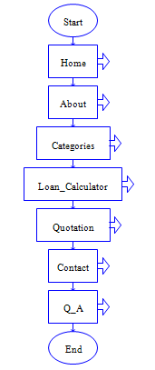

Figure 3.2 Flowchart for Main process

Figure 3.3 show flowchart for home process. The home process divide in three sections such as admin, trending, and recent posts. For the admin section contains admin questionnaire and user feedback sections. For trending section consists with new trending car models. For recent posts consists recent posts car models. The process related with main process.

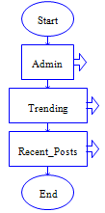

Figure 3.3 Flowchart for Home process

Figure 3.4 show flowchart for admin process. The admin process divide in two sections such admin questionnaire and user feedback. The admin require to enter private password to login to the admin system. This process related with home process.

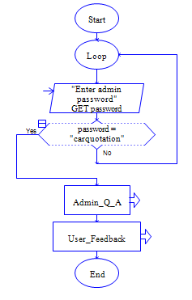

Figure 3.4 Flowchart for Admin process

Figure 3.5 show flowchart for trending process. The process consists three output for user view the trending car models. This process is related with home process.

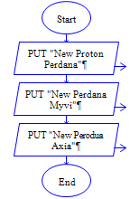

Figure 3.5 Flowchart for Trending process

Figure 3.6 show flowchart for recent post process. The process contains three output for user view the recent post of car models. The process is related with home process.

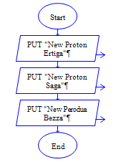

Figure 3.6 Flowchart for Recent Post process

Figure 3.7 show flowchart for admin questionnaire process. This process related with admin process. The process consist one section which is update questionnaire.

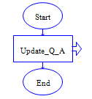

Figure 3.7 Flowchart for admin questionnaire process

Figure 3.8 show flowchart for user feedback process. The process contains two sections such as user feedback from Proton users and Perodua users. This process related with admin questionnaire process.

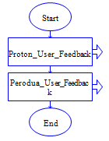

Figure 3.8 Flowchart for User Feedback process

Figure 3.9 show flowchart for update questionnaire process. The process contain outputs such as name, telephone number and user question. The administrator can reply the user question. This process related with admin questionnaire process.

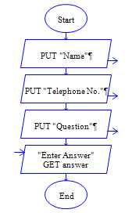

Figure 3.9 Flowchart for Update Questionnaire process

Figure 3.10 show flowchart for Proton user feedback process. The process consists of eight sections such as update Ertiga, Saga, Persona, Perdana, Iriz, Suprima, Preve, and Exora. This process related with user feedback process. The administrator can update, delete and view the Proton user feedback.

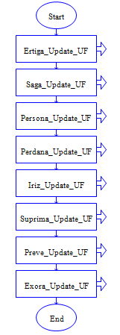

Figure 3.10 Flowchart for Proton User Feedback process

Figure 3.11 show flowchart for Perodua user feedback process. This process consists of four sections such as update Myvi, Alza, Axia, and Bezza. The process related with user feedback process. The administrator can update, delete and view the Perodua user feedback.

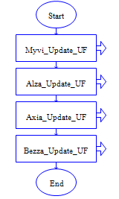

Figure 3.11 Flowchart for Perodua User Feedback process

Figure 3.12 show flowchart for about process. The process contain information of the company such history, vision and mission. This process related with main process.

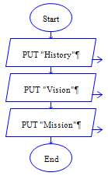

Figure 3.12 Flowchart for About process

Figure 3.13 show flowchart for car categories process. The process consist two sections such as Proton and Perodua. For Proton categories, there are eight section such as Ertiga, Saga, Persona, Perdana. For Perodua categories, there are four section such as Myvi, Alza, Axia, and Bezza. The process related with main process.

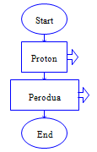

Figure 3.13 Flowchart for Car Categories process

Figure 3.14 show flowchart for car models process. This process output for car specifications such as engine, transmission, steering, braking, suspension, dimension, exterior, interior, features, safety, exterior colour, accessories, and price. The process related with car categories process.

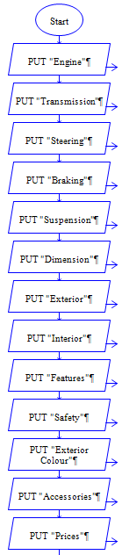

Figure 3.14 Flowchart for Car Models process

Figure 3.15 show flowchart for loan calculator process. The process consists of three input and three output. The input are amount of loan, annual interest, and repayment period. The output are monthly payment, total payment, and total interest. This process related with main process.

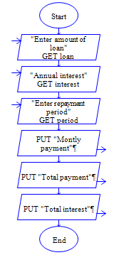

Figure 3.15 Flowchart for Loan Calculator process

Figure 3.16 show flowchart for quotation process. The process consists with four sections such as East Malaysia, Peninsular Malaysia, Labuan and Langkawi. The process related with main process.

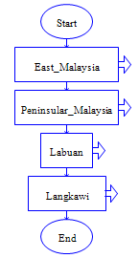

Figure 3.16 Flowchart for Quotation process

Figure 3.17 show flowchart for contact process. The process contain four output such as site map, address, phone number, and email of the company. The process also consist of a section named contact form. This process related with main process.

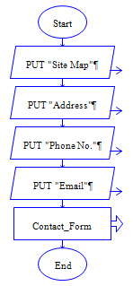

Figure 3.17 Flowchart for Contact process

Figure 3.18 show flowchart for contact form process. The process contain input for user to enter such as name, email, phone number, and message. The process related with contact process.

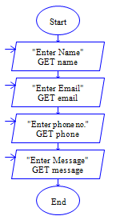

Figure 3.18 Flowchart for Contact Form process

Figure 3.19 show flowchart for questionnaire process. The process contain outputs such as user question and answer reply by the admin. The process related with main process.

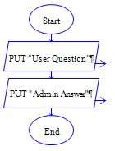

Figure 3.19 Flowchart for Questionnaire process

**3.3.2 Context Diagram**

Figure 3.20 shows context diagram of the system. A context diagram is the interaction between an entities with other entity. Also, the diagram consist with data flow and some processes. This diagram used early in the project to illustrate the data flow of the system. The objective of using context diagram in this system is to develop a system completely and organized. The user can ask question about the system by fill the question form. The user also can give feedback about car model by fill the feedback form. The data will be stored in database. The admin can view and update user question and feedback. All the updated data will be stored in the database.

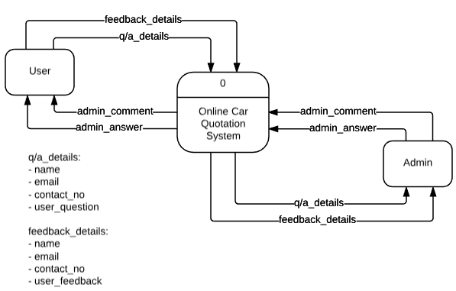

Figure 3.20 Context Diagram

**3.3.2 Level 0 Data Flow Diagram**

Figure 3.21 shows the level 0 data flow diagram of the system. User can ask any question related with the system and give feedback about the car model. Thus, the user need to fill the question form and feedback form. The admin will receive the user question and feedback. The admin can view and update the user question and feedback. All the data will be stored in database.

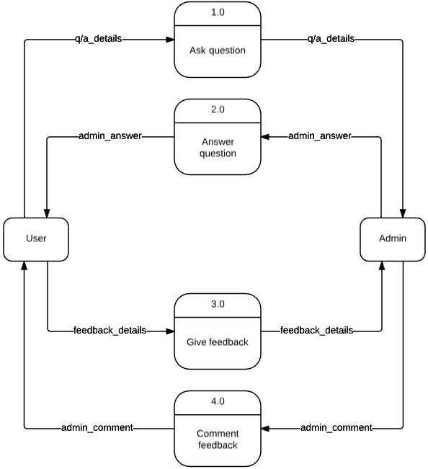

Figure 3.21 Level 0 data flow diagram

**3.3.3 Level 1 Data Flow Diagram for Ask Question process**

Figure 3.22 show the level 1 data flow diagram for Ask Question process. User need to fill the question form to ask question. The data will be store in database and can be view by the admin.

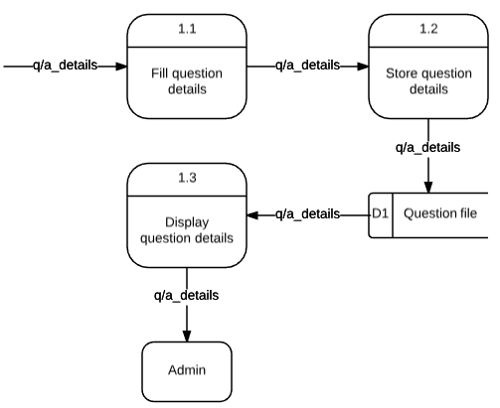

Figure 3.22 Level 1 data flow diagram for Ask Question process

**3.3.4 Level 1 Data Flow Diagram for Answer Question process**

Figure 3.23 shows the level 1 data flow diagram for Answer Question process. In this phase, admin can view the user question include user name, email, and contact number. The admin will answer the user question. The answer will display to the user.

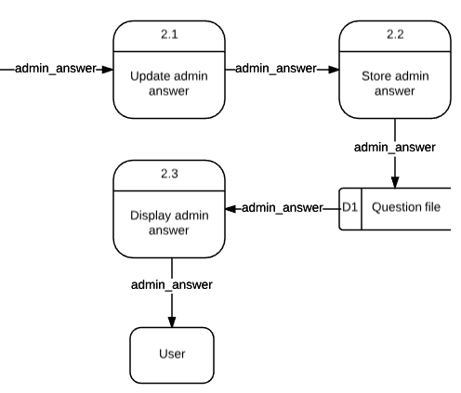

Figure 3.23 Level 1 data flow diagram for Answer Question process

**3.3.5 Level 1 Data Flow Diagram for Give Feedback process**

Figure 3.24 shows level 1 data flow diagram for Give Feedback process. This phase explained about the process occur when the user want to give feedback about the car model by fill the feedback form. The data will be stored in database and can be view by the admin.

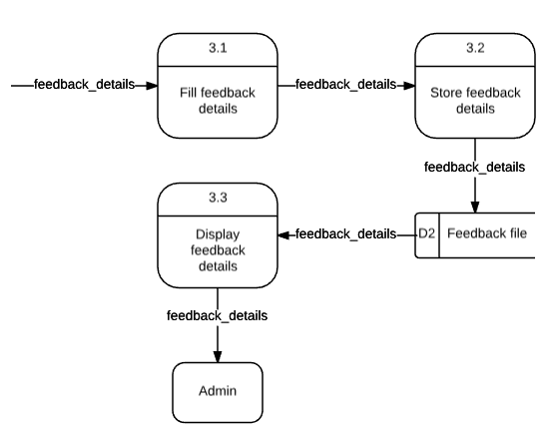

Figure 3.24 Level 1 data flow diagram for Give Feedback process

**3.3.6 Level 1 Data Flow Diagram for Comment Feedback process**

Figure 3.25 shows level 1 data flow diagram for Comment Feedback process. The admin can view the user feedback and update the feedback by comment the user feedback.

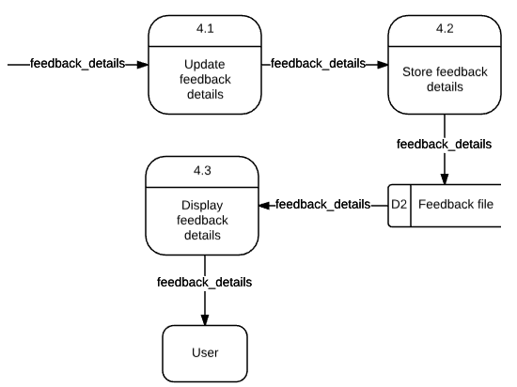

Figure 3.25 Level 1 data flow diagram for Comment Feedback process

**3.4 DESIGN PHASE**

The design phase is functional specifications of the system elements such as data process, input and output. The design phase also consists of two design which are user interface design and data design. User interface design is how the user or admin manage and use the system by add information and present the information to the system. Data design is data represented and store in the system.

**3.4.1 Database Design**

Data design is data represented and store in the system. In this phase, explanation about entity relation diagram and data dictionary.

**3.4.1.1 Entity Relation Data Diagram**

The database contains eight tables which are question file and feedback file. Figure 3.26 shows the entity relation diagram of the system. Each entities have several attributes.

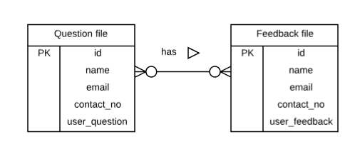

Figure 3.26 Entity relation diagram

**3.4.1.2 Data Dictionary**

Table 3.1 shows data dictionary for the Admin entity. It has an attributes which are admin password. The primary key is admin password.

Table 3.1 Data Dictionary for table Admin

|  |  |  |  |
| --- | --- | --- | --- |
| **Field** | **Description** | **Data Type** | **Constraint** |
| adminpass | Admin Password | Varchar(15) | Primary Key |

Table 3.2 shows data dictionary for Alza Feedback entity. This table has six attributes which are user ID, username, email, phone number, user message, and admin reply message. The primary key is user ID.

Table 3.2 Data Dictionary for table Alza Feedback

|  |  |  |  |
| --- | --- | --- | --- |
| **Field** | **Description** | **Data Type** | **Constraint** |
| id | User ID | Integer(15) | Primary Key |
| name | Username | Varchar(50) |  |
| email | Email | Varchar(50) |  |
| telephone | Phone Number | Integer(15) |  |
| message | User Message | Varchar(50) |  |
| reply | Admin Reply Message | Varchar(50) |  |

Table 3.3 shows data dictionary for Axia Feedback entity. This table has six attributes which are user ID, username, email, phone number, user message, and admin reply message. The primary key is user ID.

Table 3.3 Data Dictionary for table Axia Feedback

|  |  |  |  |
| --- | --- | --- | --- |
| **Field** | **Description** | **Data Type** | **Constraint** |
| id | User ID | Integer(15) | Primary Key |
| name | Username | Varchar(50) |  |
| email | Email | Varchar(50) |  |
| telephone | Phone Number | Integer(15) |  |
| message | User Message | Varchar(50) |  |
| reply | Admin Reply Message | Varchar(50) |  |

Table 3.4 shows data dictionary for Bezza Feedback entity. This table has six attributes which are user ID, username, email, phone number, user message, and admin reply message. The primary key is user ID.

Table 3.4 Data Dictionary for table Bezza Feedback

|  |  |  |  |
| --- | --- | --- | --- |
| **Field** | **Description** | **Data Type** | **Constraint** |
| id | User ID | Integer(15) | Primary Key |
| name | Username | Varchar(50) |  |
| email | Email | Varchar(50) |  |
| telephone | Phone Number | Integer(15) |  |
| message | User Message | Varchar(50) |  |
| reply | Admin Reply Message | Varchar(50) |  |

Table 3.5 shows data dictionary for Ertiga Feedback entity. This table has six attributes which are user ID, username, email, phone number, user message, and admin reply message. The primary key is user ID.

Table 3.5 Data Dictionary for table Ertiga Feedback

|  |  |  |  |
| --- | --- | --- | --- |
| **Field** | **Description** | **Data Type** | **Constraint** |
| id | User ID | Integer(15) | Primary Key |
| name | Username | Varchar(50) |  |
| email | Email | Varchar(50) |  |
| telephone | Phone Number | Integer(15) |  |
| message | User Message | Varchar(50) |  |
| reply | Admin Reply Message | Varchar(50) |  |

Table 3.6 shows data dictionary for Exora Feedback entity. This table has six attributes which are user ID, username, email, phone number, user message, and admin reply message. The primary key is user ID.

Table 3.6 Data Dictionary for table Exora Feedback

|  |  |  |  |
| --- | --- | --- | --- |
| **Field** | **Description** | **Data Type** | **Constraint** |
| id | User ID | Integer(15) | Primary Key |
| name | Username | Varchar(50) |  |
| email | Email | Varchar(50) |  |
| telephone | Phone Number | Integer(15) |  |
| message | User Message | Varchar(50) |  |
| reply | Admin Reply Message | Varchar(50) |  |

Table 3.7 shows data dictionary for Iriz Feedback entity. This table has six attributes which are user ID, username, email, phone number, user message, and admin reply message. The primary key is user ID.

Table 3.7 Data Dictionary for table Iriz Feedback

|  |  |  |  |
| --- | --- | --- | --- |
| **Field** | **Description** | **Data Type** | **Constraint** |
| id | User ID | Integer(15) | Primary Key |
| name | Username | Varchar(50) |  |
| email | Email | Varchar(50) |  |
| telephone | Phone Number | Integer(15) |  |
| message | User Message | Varchar(50) |  |
| reply | Admin Reply Message | Varchar(50) |  |

Table 3.8 shows data dictionary for Myvi Feedback entity. This table has six attributes which are user ID, username, email, phone number, user message, and admin reply message. The primary key is user ID.

Table 3.8 Data Dictionary for table Myvi Feedback

|  |  |  |  |
| --- | --- | --- | --- |
| **Field** | **Description** | **Data Type** | **Constraint** |
| id | User ID | Integer(15) | Primary Key |
| name | Username | Varchar(50) |  |
| email | Email | Varchar(50) |  |
| telephone | Phone Number | Integer(15) |  |
| message | User Message | Varchar(50) |  |
| reply | Admin Reply Message | Varchar(50) |  |

Table 3.9 shows data dictionary for Perdana Feedback entity. This table has six attributes which are user ID, username, email, phone number, user message, and admin reply message. The primary key is user ID.

Table 3.9 Data Dictionary for table Perdana Feedback

|  |  |  |  |
| --- | --- | --- | --- |
| **Field** | **Description** | **Data Type** | **Constraint** |
| id | User ID | Integer(15) | Primary Key |
| name | Username | Varchar(50) |  |
| email | Email | Varchar(50) |  |
| telephone | Phone Number | Integer(15) |  |
| message | User Message | Varchar(50) |  |
| reply | Admin Reply Message | Varchar(50) |  |

Table 3.10 shows data dictionary for Persona Feedback entity. This table has six attributes which are user ID, username, email, phone number, user message, and admin reply message. The primary key is user ID.

Table 3.10 Data Dictionary for table Persona Feedback

|  |  |  |  |
| --- | --- | --- | --- |
| **Field** | **Description** | **Data Type** | **Constraint** |
| id | User ID | Integer(15) | Primary Key |
| name | Username | Varchar(50) |  |
| email | Email | Varchar(50) |  |
| telephone | Phone Number | Integer(15) |  |
| message | User Message | Varchar(50) |  |
| reply | Admin Reply Message | Varchar(50) |  |

Table 3.11 shows data dictionary for Preve Feedback entity. This table has six attributes which are user ID, username, email, phone number, user message, and admin reply message. The primary key is user ID.

Table 3.11 Data Dictionary for table Preve Feedback

|  |  |  |  |
| --- | --- | --- | --- |
| **Field** | **Description** | **Data Type** | **Constraint** |
| id | User ID | Integer(15) | Primary Key |
| name | Username | Varchar(50) |  |
| email | Email | Varchar(50) |  |
| telephone | Phone Number | Integer(15) |  |
| message | User Message | Varchar(50) |  |
| reply | Admin Reply Message | Varchar(50) |  |

Table 3.12 shows data dictionary for Saga Feedback entity. This table has six attributes which are user ID, username, email, phone number, user message, and admin reply message. The primary key is user ID.

Table 3.12 Data Dictionary for table Saga Feedback

|  |  |  |  |
| --- | --- | --- | --- |
| **Field** | **Description** | **Data Type** | **Constraint** |
| id | User ID | Integer(15) | Primary Key |
| name | Username | Varchar(50) |  |
| email | Email | Varchar(50) |  |
| telephone | Phone Number | Integer(15) |  |
| message | User Message | Varchar(50) |  |
| reply | Admin Reply Message | Varchar(50) |  |

Table 3.13 shows data dictionary for Suprima Feedback entity. This table has six attributes which are user ID, username, email, phone number, user message, and admin reply message. The primary key is user ID.

Table 3.13 Data Dictionary for table Suprima Feedback

|  |  |  |  |
| --- | --- | --- | --- |
| **Field** | **Description** | **Data Type** | **Constraint** |
| id | User ID | Integer(15) | Primary Key |
| name | Username | Varchar(50) |  |
| email | Email | Varchar(50) |  |
| telephone | Phone Number | Integer(15) |  |
| message | User Message | Varchar(50) |  |
| reply | Admin Reply Message | Varchar(50) |  |

Table 3.14 shows data dictionary for Contact entity. This table has six attributes which are user ID, username, email, phone number, user message, and admin reply message. The primary key is user ID.

Table 3.14 Data Dictionary for table Contact

|  |  |  |  |
| --- | --- | --- | --- |
| **Field** | **Description** | **Data Type** | **Constraint** |
| id | User ID | Integer(15) | Primary Key |
| name | Username | Varchar(50) |  |
| email | Email | Varchar(50) |  |
| telephone | Phone Number | Integer(15) |  |
| message | User Message | Varchar(50) |  |
| reply | Admin Reply Message | Varchar(50) |  |

**3.4.2 User Interface Design**

User interface design represents the user interface for the user or admin to manage and use the system. There are several graphical user interface that have been proposed for this system which followed the principle of graphical user interface.

Figure 3.27 show the user interface for Home. The user can view the latest and future car models at the slideshow images in this page. The trending and recent post are provided to ease the user for finding new car models. The admin button is used for administrator only. The read more button is linked to the about us page.

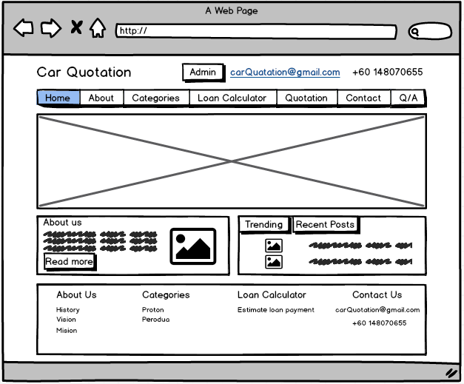

Figure 3.27 User Interface for Home

Figure 3.28 shows the user interface for About. The user can view and read the history, vision and mission of Car Quotation company.

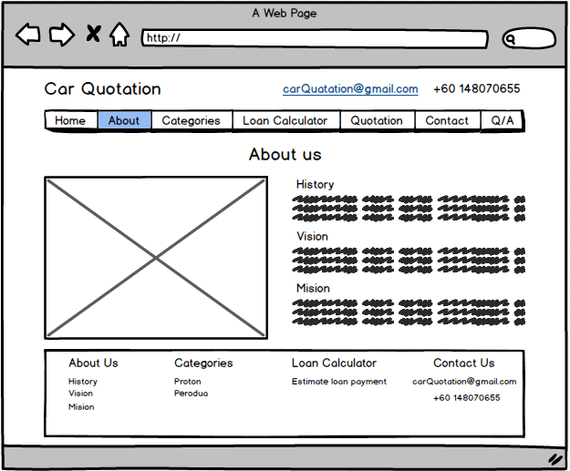

Figure 3.28 User Interface for About

Figure 3.39 shows the user interface for Proton Model. The user can choose any car models. After that, the user can view the car model specifications.

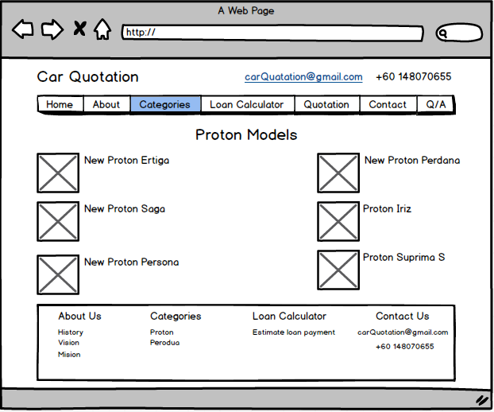

Figure 3.29 User Interface for Proton Model

Figure 3.30 shows the user interface for Perodua Model. The user can choose any car models. After that, the user can view the car model specifications.

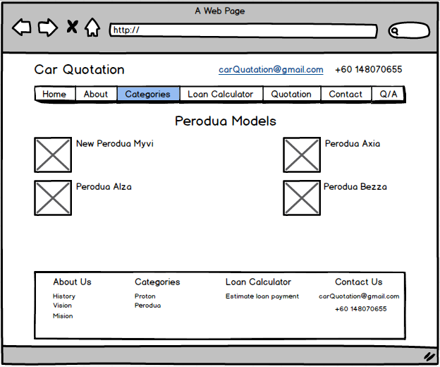

Figure 3.30 User Interface for Perodua Model

Figure 3.31 shows the user interface for Car Model Specifications. The user can view all three classes of car model specifications. The user also can read all other user feedback about the car model and can leave a comment or feedback about the car model. The user need to fill the form with username, email, contact number and the feedback about this car model.

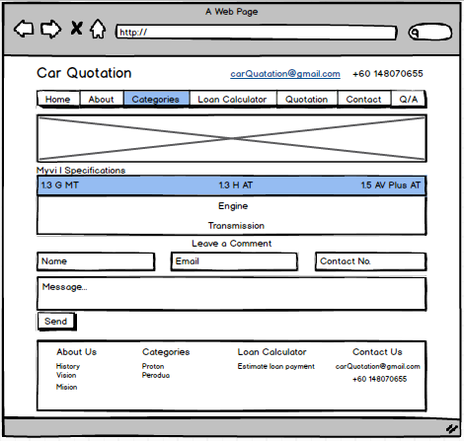

Figure 3.31 User Interface for Car Model Specifications

Figure 3.32 shows the user interface Loan Calculator. The user can estimate the loan payment by fill in the information such as amount of the loan, annual interest, and the repayment period. Then, the user can view the approximate payments such as monthly payment, total payment and total interest. The graph also provided to user to see the increasing and the decreasing of the total payment, amount of the loan and the repayment period.

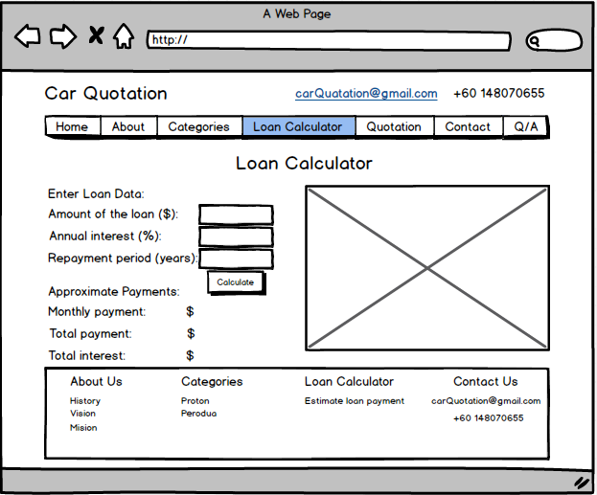

Figure 3.32 User Interface for Loan Calculator

Figure 3.33 shows the user interface for Quotation. The user can select the range of the car price and the location of company branches. After that, the user can view the suitable car models based on the range price and the location of company branches.

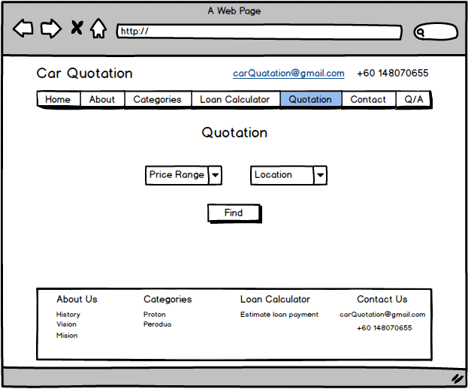

Figure 3.33 User Interface for Quotation

Figure 3.34 shows the user interface for Contact. The user can view all the information such as the company map, address, contact number, and email. The user also can ask any question that related with our company by fill in the contact form. The user need to fill all information such as username, email, contact number and the question.

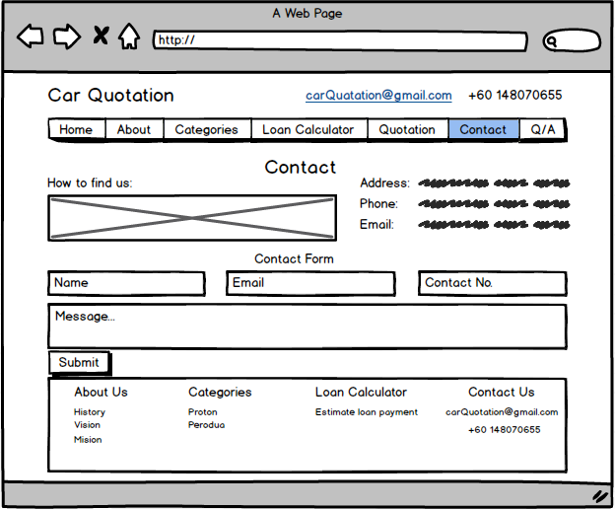

Figure 3.34 User Interface for Contact

Figure 3.35 shows the user interface for Questionnaire. The user can view the reply messages from the company administrator and the other user questions.

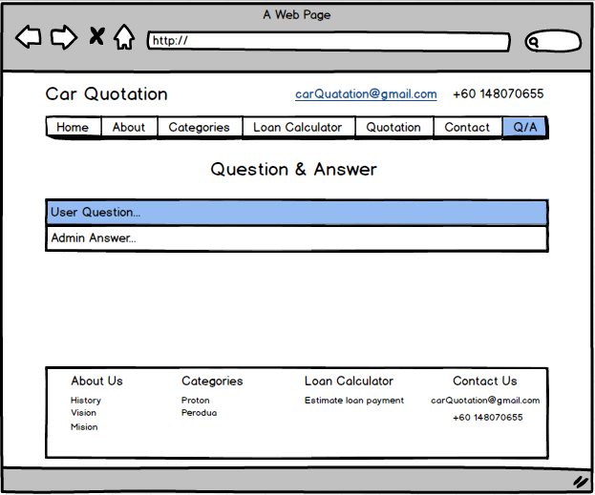

Figure 3.35 User Interface for Questionnaire

Figure 3.36 shows the user interface for Admin Login. Administrator need to key in password to get access into system. Cancel button is linked to home page of the Car Quotation system. After the administrator click login button, it will linked to admin main page.

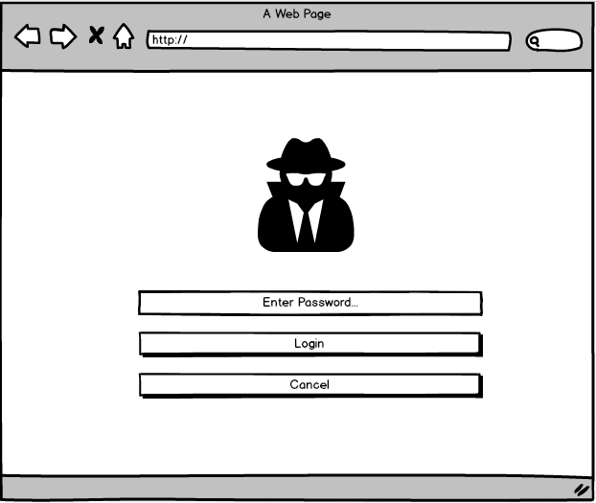

Figure 3.36 User Interface for Admin Login

Figure 3.37 shows the user interface for Main Admin. The administrator can choose and click either q/a button or user feedback button. Question and answer (q/a) button is linked to question and answer display page while user feedback button is linked to user feedback display page. Then, the logout button is linked to home page of Car Quotation system.

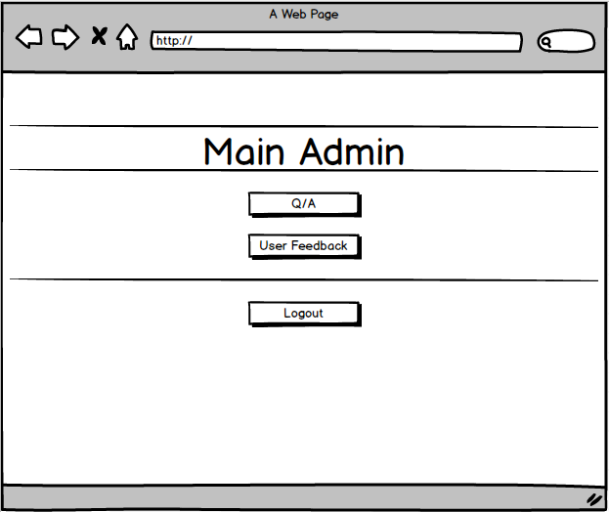

Figure 3.37 User Interface for Main Admin

Figure 3.38 shows the Questionnaire interface for display user information. The administrator can view all the user information such as email, username, phone number, user question and the answer but the answer need to reply first by the administrator then it can be view in this page. Reply button is linked to question and answer update page. The return button will go back to previous page which is admin main page. Then, the logout button is linked to homepage of the Car Quotation system.

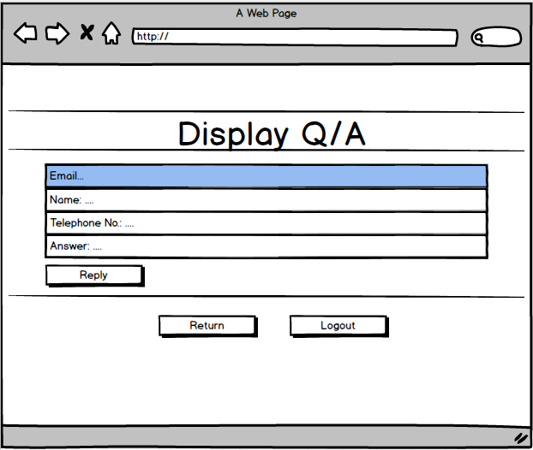

Figure 3.38 Questionnaire interface for display user information

Figure 3.39 shows the Questionnaire interface for update user information in the system for admin. The administrator can reply the user question in the given text box. The update button will save the user data. The answer also can be reset by clicking reset button and delete button for delete all the data of this user. The return button is linked to question and answer display page and the logout button is linked to homepage of the system.

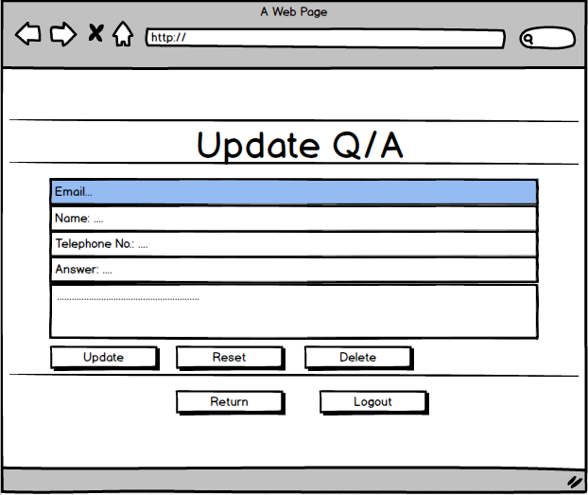

Figure 3.39 Questionnaire interface for update user information

Figure 3.40 shows the User Feedback interface for car categories in this system. The administrator can choose the car categories which is Proton models and Perodua models. The Proton button is linked to Proton models page while the Perodua button is linked to Perodua models page. The return button is linked to admin main page.

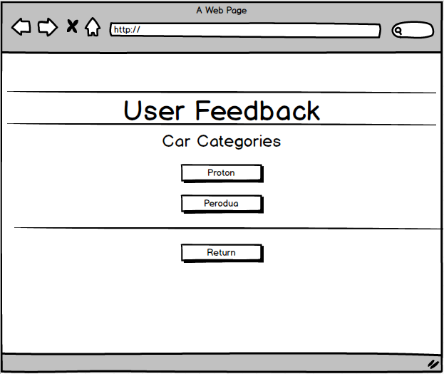

Figure 3.40 User Feedback interface for car categories

Figure 3.41 shows the User Feedback interface for Proton models. The administrator can choose any car models. Each car models button linked to user feedback page for each car models followed the chosen car model. The return button is linked to user feedback page for car categories.

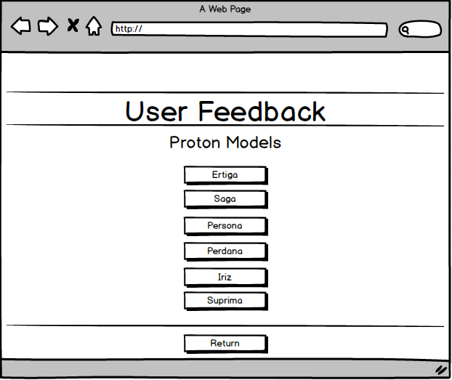

Figure 3.41 User Feedback interface for Proton models

Figure 3.42 shows the User Feedback interface for Perodua models. The administrator can choose any car models. Each car models button linked to user feedback page for each car models followed the chosen car model. The return button is linked to user feedback page for car categories.

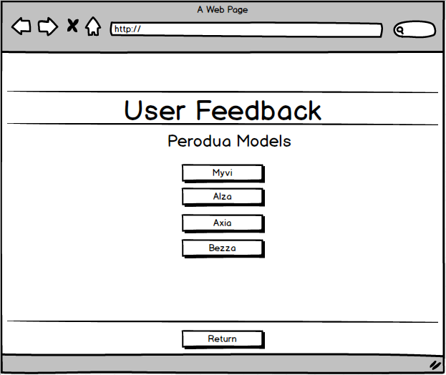

Figure 3.42 User Feedback interface for Perodua models

Figure 3.43 shows the User Feedback interface for display car’s user information. The administrator can view all the user information such as email, username, phone number, user feedback and the admin reply message but it need to reply first by the administrator then it can be view in this page. Reply button is linked to user feedback page for update car’s user information. The return button will go back to previous page which is user feedback page for car models. Then, the logout button is linked to homepage of the Car Quotation system.

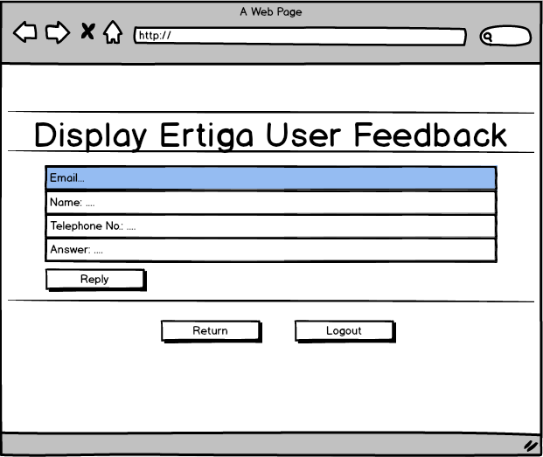

Figure 3.43 User Feedback interface for display car’s user information

Figure 3.44 shows the User Feedback for update car’s user information. The administrator can reply the user feedback in the given text box. The answer also can be reset by clicking reset button and delete button for delete all the data of this user. The return button is linked to user feedback for display car’s user information and the logout button is linked to homepage of the system.

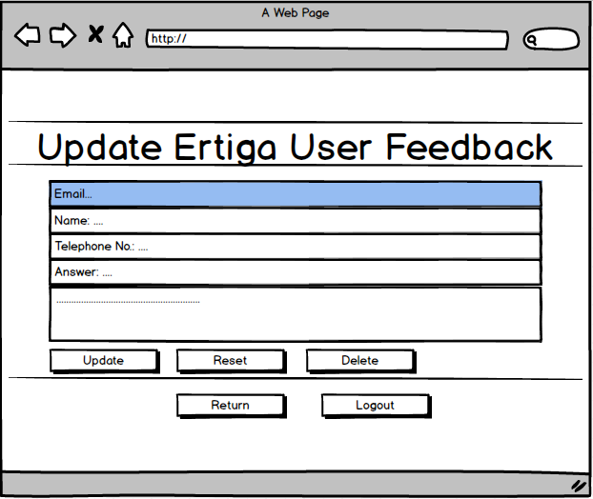

Figure 3.44 User Feedback for update car’s user information

**3.5 IMPLEMENTATION PHASE**

Main goals of the proposed system are completely succeed in this stage. This proposed system is coded, tested, and installed. The system will be coded in many languages such as HTML5, MySQL, PHP, and Web Application. Admin and user will test this system which based on the user acceptance form. The user acceptance result will be used to improve the system. Then, the system are ready to be installed and use by the user.

**3.5.1 User Acceptance Test (UAT)**

For this phase, user and admin need to test the system for the user acceptance evaluation. The result shows any problem occur in the system that need to be fix and improved. The user and admin also need to fill user acceptance test form and comment to evaluate the system. The user acceptance test form will divided by two form which are user acceptance test for user and user acceptance for admin.

**3.5.1.1 User Acceptance Test for User**

Table 3.15 show user acceptance test form for user consist with acceptance requirement, critical, test result and comment. The user need to fill all the requirement for maintenance for the system.

Table 3.15 User Acceptance Test Form for User

|  |  |  |  |  |  |  |
| --- | --- | --- | --- | --- | --- | --- |
| Name | |  | | | | |
| ID | |  | | | | |
| User Categories | | User | | | | |
| Date | |  | | | | |
| Signature | |  | | | | |
| No. | Acceptance Requirement | Critical | | Test Result | | Comment |
| Yes | No | Accept | Reject |
| 1 | User can navigate using menu |  |  |  |  |  |
| 2 | User can view trending car models |  |  |  |  |  |
| 3 | User can fill contact form |  |  |  |  |  |
| 4 | User can understand properly the company information |  |  |  |  |  |
| 5 | User can select the car model based on car categories |  |  |  |  |  |
| 6 | User can go to social media website by clicking social media image button |  |  |  |  |  |
| 7 | User can fill the loan calculator form |  |  |  |  |  |
| 8 | User can view car specification |  |  |  |  |  |
| 9 | User can view approximate payments |  |  |  |  |  |
| 10 | User can select car model based on range price and location |  |  |  |  |  |

**3.5.1.2 User Acceptance Test for Admin**

Table 3.16 show user acceptance test form for admin consist with acceptance requirement, critical, test result and comment. The admin need to fill all the requirement for maintenance for the system.

Table 3.16 User Acceptance Test Form for Admin

|  |  |  |  |  |  |  |
| --- | --- | --- | --- | --- | --- | --- |
| Name | |  | | | | |
| ID | |  | | | | |
| User Categories | | Admin | | | | |
| Date | |  | | | | |
| Signature | |  | | | | |
| No. | Acceptance Requirement | Critical | | Test Result | | Comment |
| Yes | No | Accept | Reject |
| 1 | Admin can login to main admin page |  |  |  |  |  |
| 2 | Admin can view all the interface |  |  |  |  |  |
| 3 | Admin understand the use of add, edit and delete button |  |  |  |  |  |
| 4 | Admin can edit admin details easily |  |  |  |  |  |
| 5 | Admin can delete car specifications |  |  |  |  |  |
| 6 | Admin can reply user feedback in the system |  |  |  |  |  |
| 7 | Admin can reset the user information |  |  |  |  |  |
| 8 | Admin can reply user question completely |  |  |  |  |  |
| 9 | Admin can return to previous page by clicking return button |  |  |  |  |  |
| 10 | Admin can logout from the system |  |  |  |  |  |

**3.6 MAINTENANCE PHASE**

Maintenance process will be done when the system has been operated. Maintenance of the system include system repairs, upgrades, and fixes if there are some problem in the system. Feedback from the user is important that will be used to improve the system to become more efficient. If there are any improvement in the system, the maintenance should be done by return back to the previous system steps of the SDLC. The maintenance is also to ensure that the system is updated.

**3.7 GANTT CHART**

The Gantt chart shows the schedule of the project will be conducted within the timeframe. All particular subtopic have been completed on time based on supervisor instruction. The project consist three chapter which are introduction, review of existing system and methodology. Figure 3.45 show the Gantt chart for this project report.

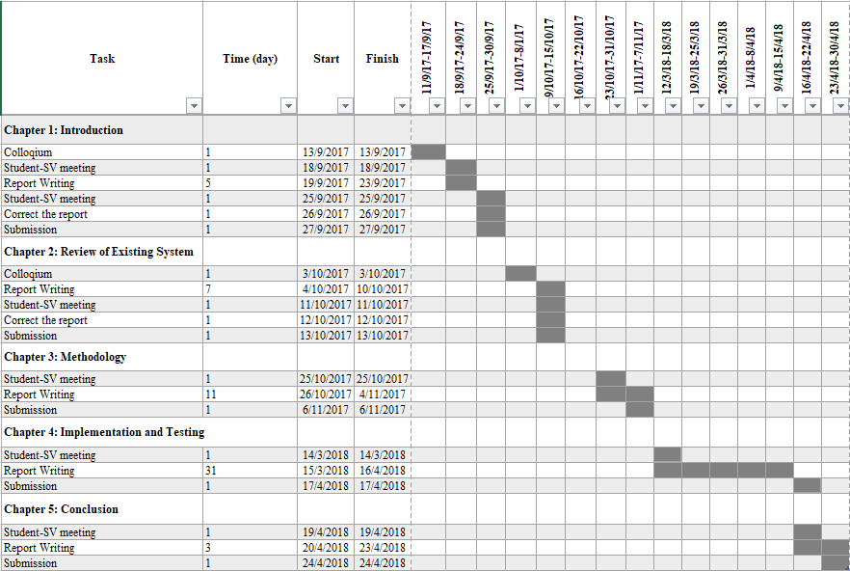

Figure 3.45 Gantt chart for Project Report

**3.8 CONCLUSION**

In conclusion, chapter three discuss about the methodology of existing systems. This chapter consists with eight subtopic which are system development life cycle, system requirement, user requirement, proposed design, database design, user interface design, user acceptance test, and Gantt chart.

**CHAPTER 4**

**IMPLEMENTATION AND TESTING**

**4.1 INTRODUCTION**

This chapter explain about the implementation of the project. Moreover, this chapter also discuss about the process of the system flow and data that will retrieve from the user. All the functional and non-functional requirement will be test by the user to get their feedback.

In this chapter consists with few sub-sections. The first section explaining the implementation process which describes about the web service method that used in Car Quotation system. In addition, the second section describes about the user manual that need to follow by the user. The final section, the test will be conduct by the user to test the system. All the result will recorded in user acceptance test form.

**4.2 IMPLEMENTATION PROCESS**

The system is developed by using web service method. The Web Service defined as the service that suitable for business communication with each other. It also can be describes as the communication between two electronic devices over World Wide Web (WWW). In this system, the interaction between admin and user are important because the user will ask any question related with this system or feedback about the car models. Then, the admin will achieve the recorded data and will reply all the feedback and question to user.

The HTML5 stand for Hypertext Mark-up Language 5 is the programming language that used to develop the system content which is the input from the user. Then, JavaScript is used for conditional statement in validation of admin information. The PHP language is used for conditional statement for searching car specifications and also used for integration with SQL database.

**4.3 USER MANUAL**

This section describes about the function of the user interfaces in the system. The user manual consists with two part which are admin and user. All the figures will explain the function of each interfaces to give guideline for user use this system.

**4.3.1 Admin**

Figure 4.1 shows the login page for admin. Administrator need to key in password to get access into system. Cancel button is linked to home page of the Car Quotation system. After the administrator click login button, it will linked to admin main page.

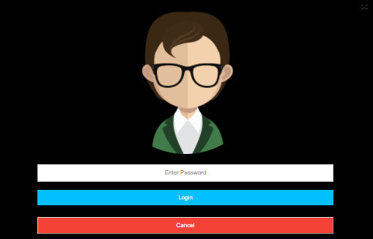

Return to homepage

Linked to admin main page

Fill in admin password

Figure 4.1 Login page for Admin

Figure 4.2 shows the main admin page of the system for admin. The administrator can choose and click either q/a button or user feedback button. Question and answer (q/a) button is linked to question and answer display page while user feedback button is linked to user feedback display page. Then, the logout button is linked to home page of Car Quotation system.



Linked to user home page

Linked to user feedback display page

Linked to q/a display page

Figure 4.2 Main Admin page

Figure 4.3 shows the question and answer page for display user information. The administrator can view all the user information such as email, username, phone number, user question and the answer but the answer need to reply first by the administrator then it can be view in this page. Reply button is linked to question and answer update page. The return button will go back to previous page which is admin main page. Then, the logout button is linked to homepage of the Car Quotation system.

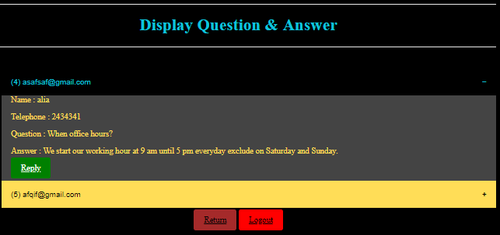

Linked to home page

Linked to admin main page

Linked to q/a update page

Figure 4.3 Question and Answer page for Display User Information

Figure 4.4 shows the question and answer page for update user information in the system for admin. The administrator can reply the user question in the given text box. The update button will save the user data. The answer also can be reset by clicking reset button and delete button for delete all the data of this user. The return button is linked to question and answer display page and the logout button is linked to homepage of the system.

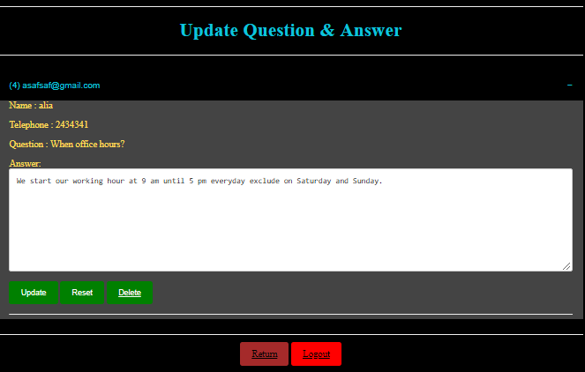

Reset answer form

Fill in answer form

Linked to q/a display page

Linked to home page

Delete user data

Save user data

Figure 4.4 Question and Answer page for update user information

Figure 4.5 shows the user feedback page for car categories in this system. The administrator can choose the car categories which is Proton models and Perodua models. The Proton button is linked to Proton models page while the Perodua button is linked to Perodua models page. The return button is linked to admin main page.



Linked to admin main page

Linked to Perodua models page

Linked to Proton models page

Figure 4.5 User Feedback page for Car Categories

Figure 4.6 shows the user feedback page for car models. The administrator can choose any car models. Each car models button linked to user feedback page for each car models followed the chosen car model. The return button is linked to user feedback page for car categories.

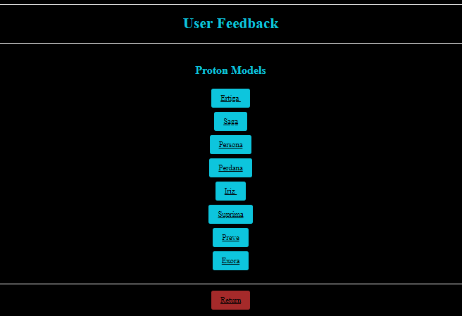

Linked to user feedback page for car categories

Linked to user feedback page for each car models

Figure 4.6 User Feedback page for Car Models

Figure 4.7 shows the user feedback page for display car’s user information. The administrator can view all the user information such as email, username, phone number, user feedback and the admin reply message but it need to reply first by the administrator then it can be view in this page. Reply button is linked to user feedback page for update car’s user information. The return button will go back to previous page which is user feedback page for car models. Then, the logout button is linked to homepage of the Car Quotation system.

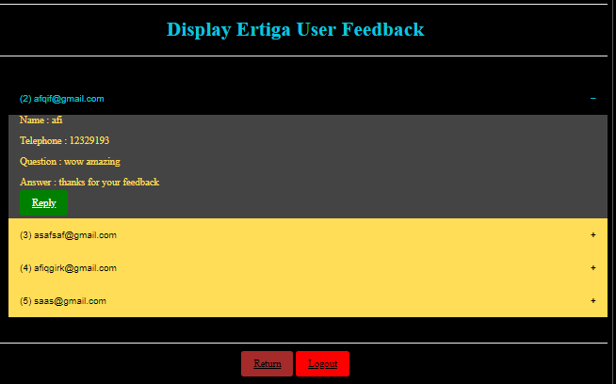

Linked to home page

Linked to user feedback page for car models

Linked to user feedback page for update car’s user information

Figure 4.7 User Feedback page for Display Car’s User Information

Figure 4.8 shows the user feedback for update car’s user information. The administrator can reply the user feedback in the given text box. The answer also can be reset by clicking reset button and delete button for delete all the data of this user. The return button is linked to user feedback for display car’s user information and the logout button is linked to homepage of the system.

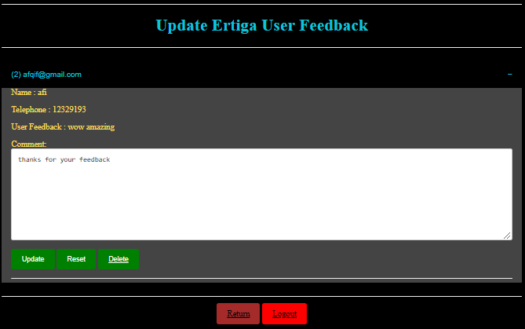

Linked to home page

Linked to user feedback for display car’s user information

Delete user data

Reset comment form

Save user data

Fill in comment form

Figure 4.8 User Feedback page for Update Car’s User Information

**4.3.2 User**

Figure 4.9 shows the Car Quotation system homepage for user. The user can view the latest and future car models at the slideshow images in this page. The trending and recent post are provided to ease the user for finding new car models. The admin button is used for administrator only. The read more button is linked to the about us page.

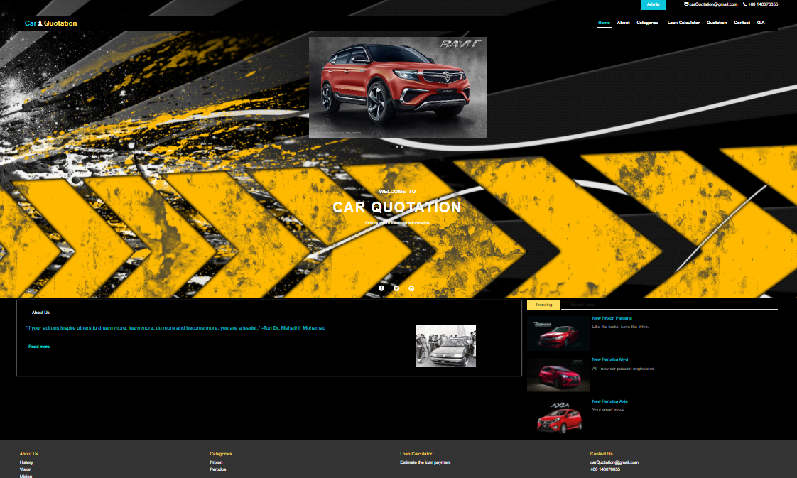

Linked to trending and recent post car models page

Linked to admin login form

Linked to about us page

View latest and future car models at slideshow images

Figure 4.9 Car Quotation System Homepage for User

Figure 4.10 shows the about us page of Car Quotation company. The user can view and read the history, vision and mission of Car Quotation company.

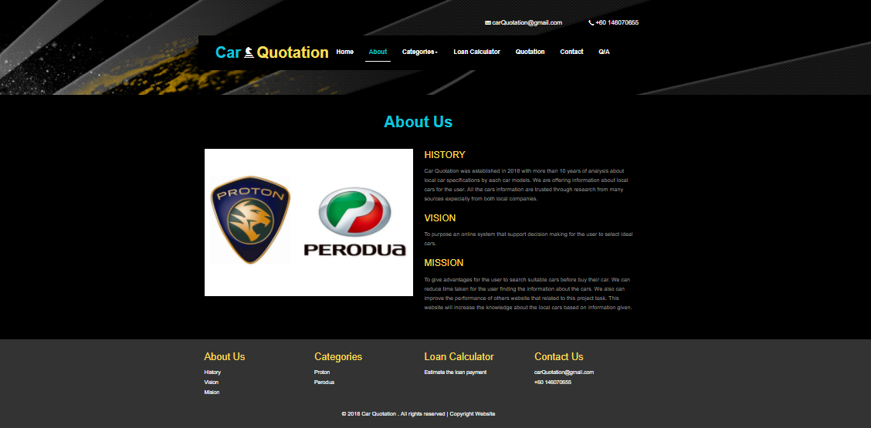

Linked to email webpage

Linked to about us page

Linked to email webpage

Figure 4.10 About Us page

Figure 4.11 shows the car models page for user. The user can choose any car models. After that, the user can view the car model specifications.

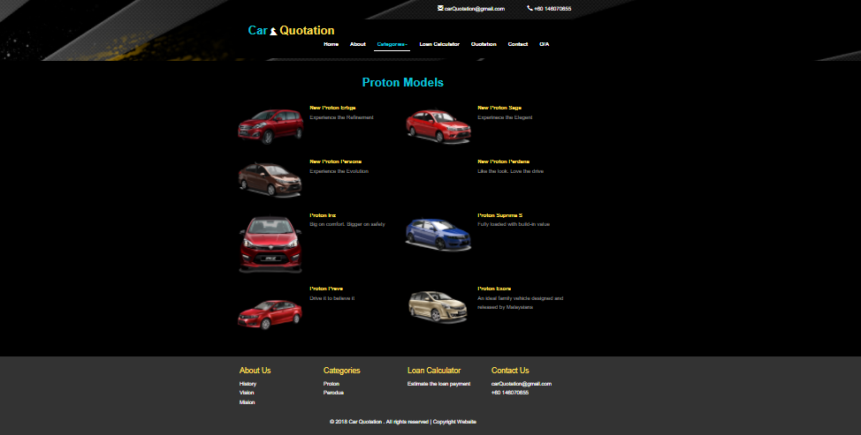

Linked to car models page for each Proton models

Linked to loan calculator page

Linked to car models page for each categories

Figure 4.11 Car Models page

Figure 4.12 shows the car model specifications page. The user can view all three classes of car model specifications. The user also can read all other user feedback about the car model and can leave a comment or feedback about the car model. The user need to fill the form with username, email, contact number and the feedback about this car model.

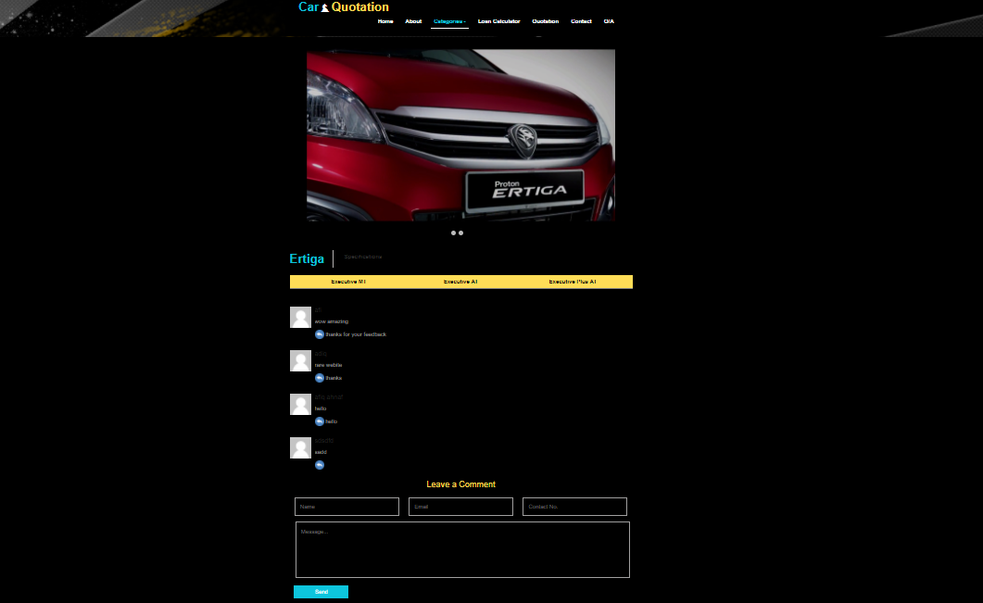

Fill in user information and feedback

Show user feedback for the car model

Show car specifications information

Figure 4.12 Car Model Specifications page

Figure 4.13 shows the loan calculator page for user. The user can estimate the loan payment by fill in the information such as amount of the loan, annual interest, and the repayment period. Then, the user can view the approximate payments such as monthly payment, total payment and total interest. The graph also provided to user to see the increasing and the decreasing of the total payment, amount of the loan and the repayment period.

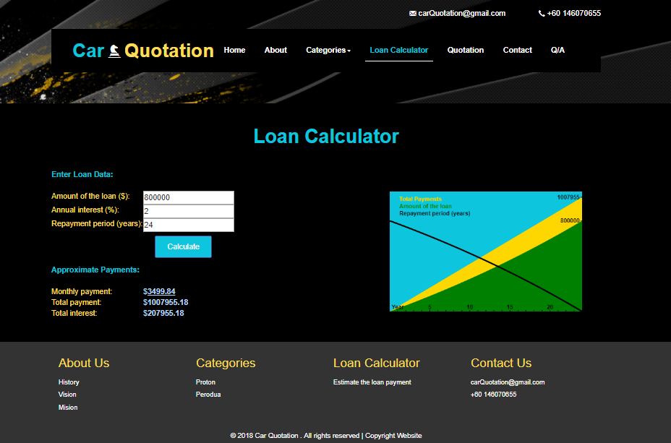

Calculate all loan details

Graph for loan details

Approximate payment

Fill in loan details

Figure 4.13 Loan Calculator page

Figure 4.14 shows the quotation page for user. The user can select the range of the car price and the location of company branches. After that, the user can view the suitable car models based on the range price and the location of company branches.

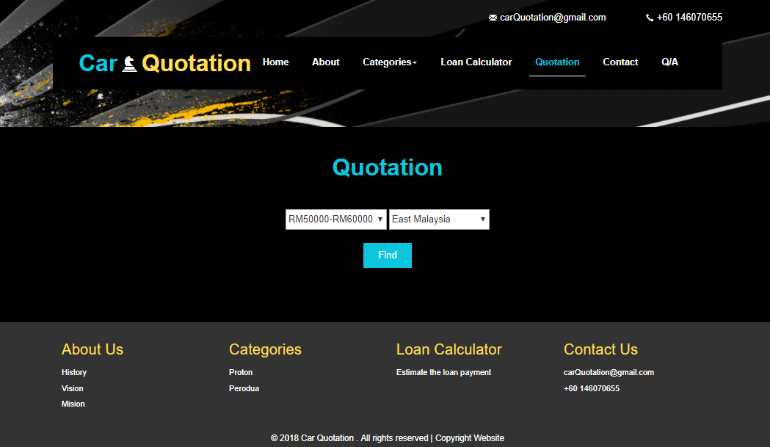

Linked to suitable car models page

Select branches location for car models

Select price range for car models

Figure 4.14 Quotation page

Figure 4.15 shows the suitable car models page. The user can view all suitable car models based on the range of car model price and the location of company branches.

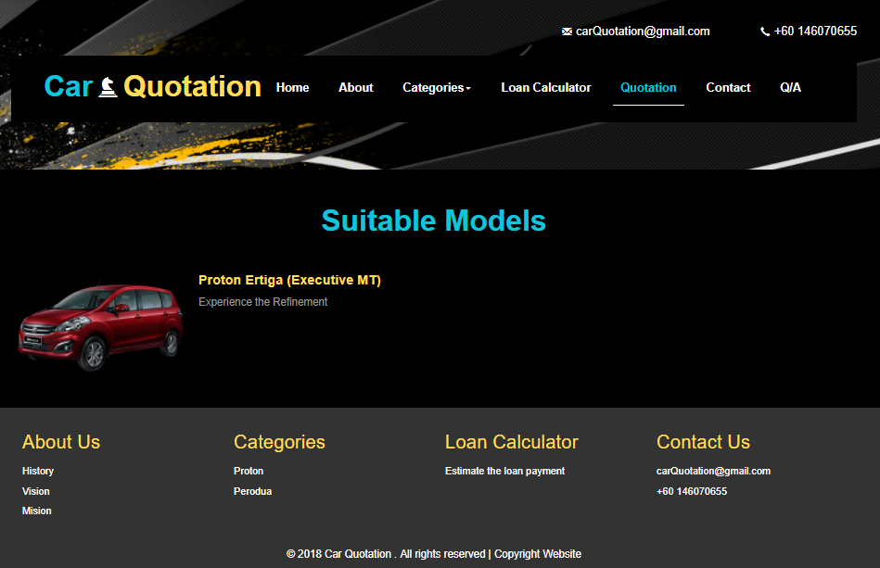

Linked to car specification page for the car model

Figure 4.15 Suitable Car Models page

Figure 4.16 shows the suitable car models specification page that had been filter based on range of the car models price and the location of the company branches. The user can view car specifications information. The user also can read all other user feedback and leave their feedback by fill in the form given. The form consists with username, email, contact number and the feedback about the car model.

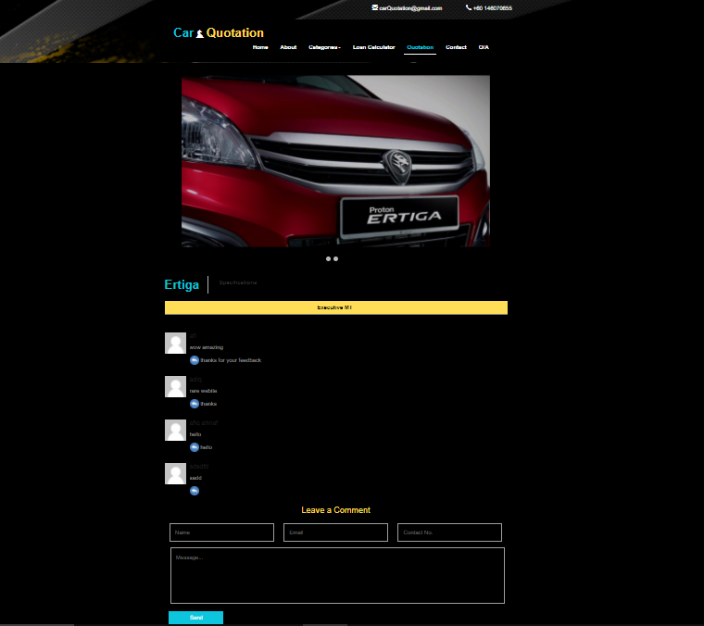

Fill in user information and feedback

Show car specifications information

Show user feedback for the car model

Submit the user feedback to admin user feedback page

Figure 4.16 Suitable Car Models Specifications page

Figure 4.17 shows the contact us page for the user. The user can view all the information such as the company map, address, contact number, and email. The user also can ask any question that related with our company by fill in the contact form. The user need to fill all information such as username, email, contact number and the question.

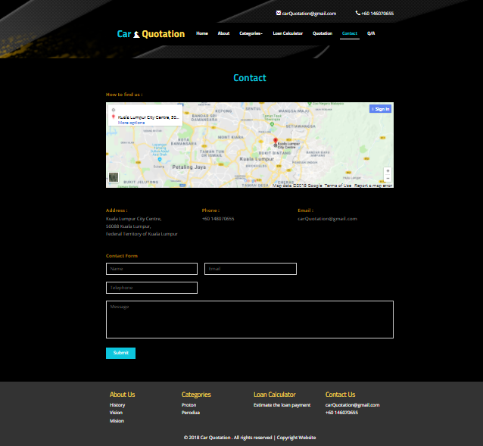

Submit the user question to admin user q/a page

Show the company location

Fill in user information and question

Figure 4.17 Contact Us page

Figure 4.18 shows the question and answer page for user. The user can view the reply messages from the company administrator and the other user questions.

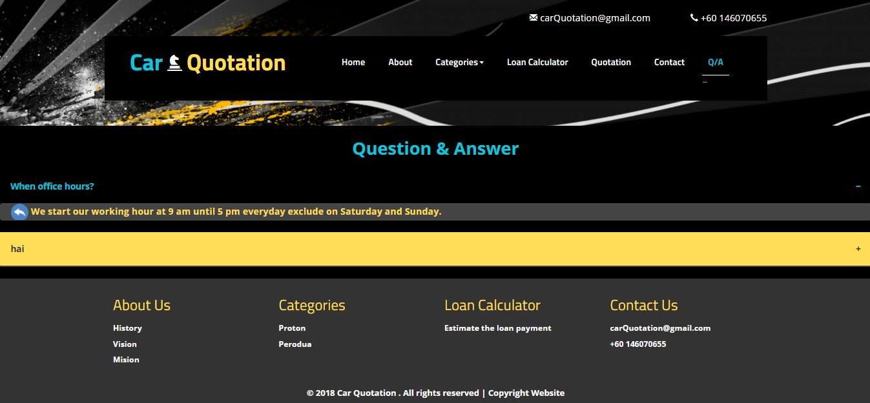

Show admin answer

Show user question

Figure 4.18 Question and Answer for User page

**4.4 IMPLEMENTATION OF DATABASE**

This section discuss about the testing of the Car Quotation system with the SQL database. All the information that had been fill by the user or admin will be recorded in this database called Car Quotation database. There are several table that had been created to record all the information. All the figures explain each of the tables.

Figure 4.19 shows the admin table in Car Quotation database. The admin password as shown in Figure 4.1 are stored in this table.

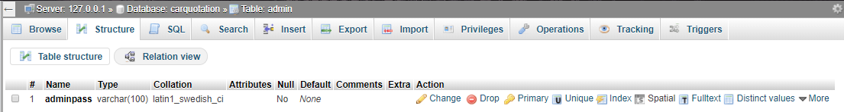

Figure 4.19 Admin table in Car Quotation database

Figure 4.20 shows the Perodua Alza user feedback table in Car Quotation database. Updating and deleting of user information are stored in this table.

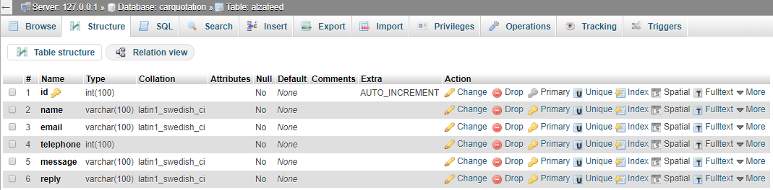

Figure 4.20 Perodua Alza User Feedback table in Car Quotation database

Figure 4.21 shows the Perodua Axia user feedback table in Car Quotation database. Updating and deleting of user information are stored in this table.

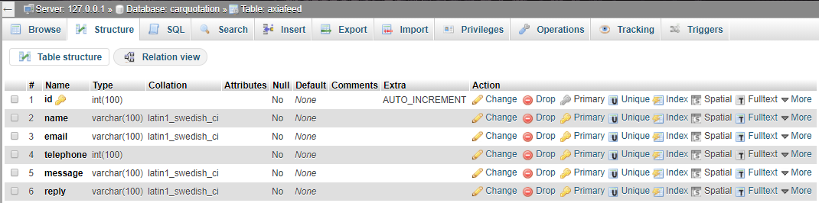

Figure 4.21 Perodua Axia user feedback table in Car Quotation database

Figure 4.22 shows the Perodua Bezza user feedback table in Car Quotation database. Updating and deleting of user information are stored in this table.

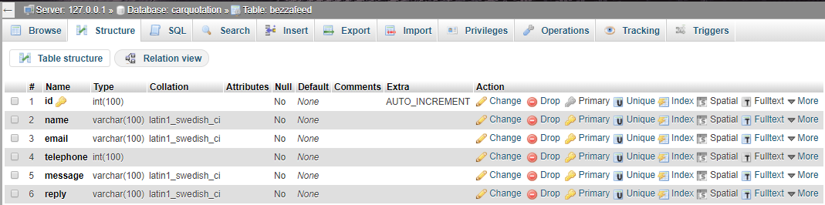

Figure 4.22 Perodua Bezza user feedback table in Car Quotation database

Figure 4.23 shows the contact table in Car Quotation database. Updating and deleting of user information as shown Figure 4.4 are stored in this table.

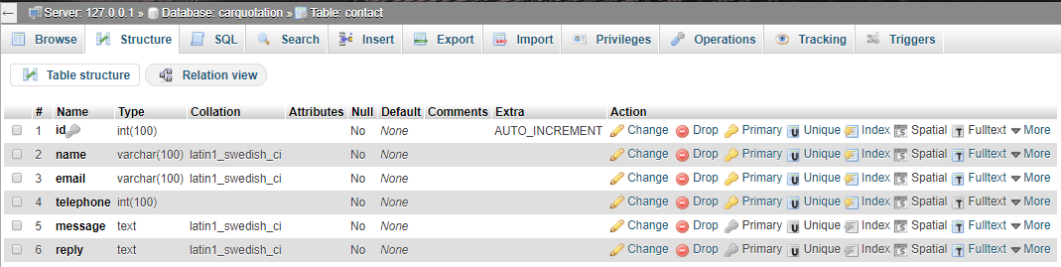

Figure 4.23 Contact table in Car Quotation database

Figure 4.24 shows the Proton Ertiga user feedback table in Car Quotation database. Updating and deleting of user information are stored in this table.

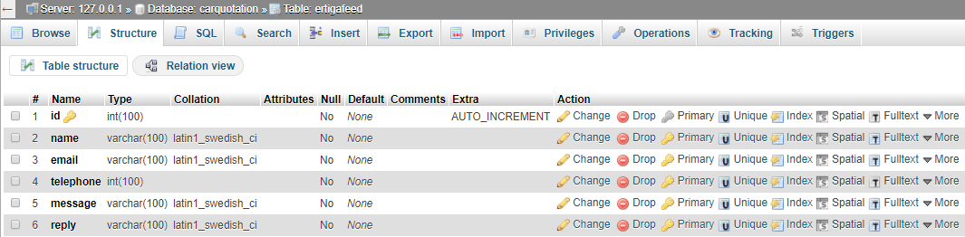

Figure 4.24 Proton Ertiga user feedback table in Car Quotation database

Figure 4.25 shows the Proton Exora user feedback table in Car Quotation database. Updating and deleting of user information are stored in this table.

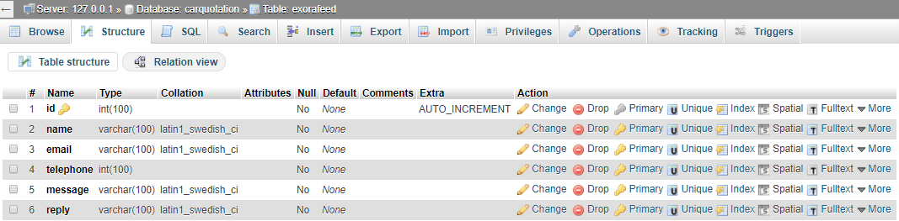

Figure 4.25 Proton Exora user feedback table in Car Quotation database

Figure 4.26 shows the Perodua Iriz user feedback table in Car Quotation database. Updating and deleting of user information are stored in this table.

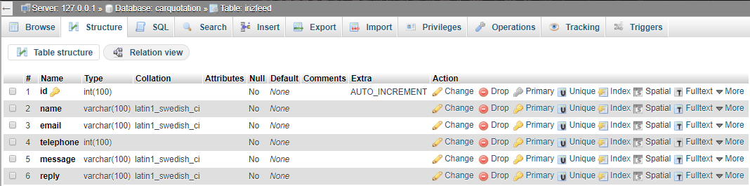

Figure 4.26 Perodua Iriz user feedback table in Car Quotation database

Figure 4.27 shows the Perodua Myvi user feedback table in Car Quotation database. Updating and deleting of user information are stored in this table.

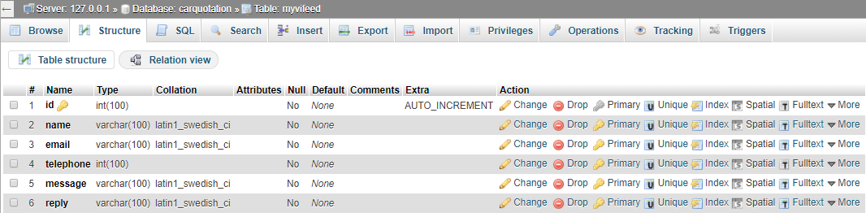

Figure 4.27 Perodua Myvi user feedback table in Car Quotation database

Figure 4.28 shows the Proton Perdana user feedback table in Car Quotation database. Updating and deleting of user information are stored in this table.

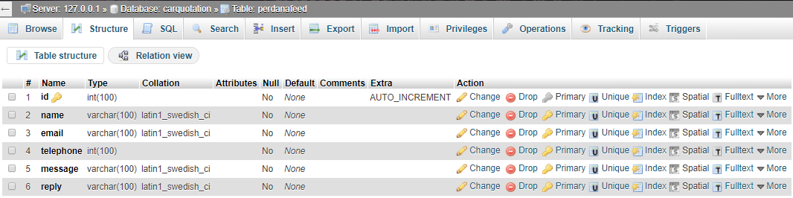

Figure 4.28 Proton Perdana user feedback table in Car Quotation database

Figure 4.29 shows the Proton Persona user feedback table in Car Quotation database. Updating and deleting of user information are stored in this table.

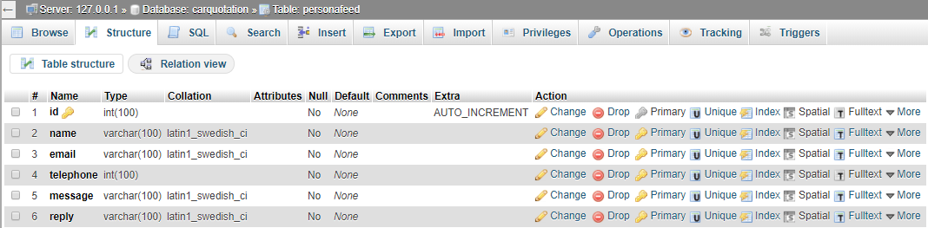

Figure 4.29 Proton Persona user feedback table in Car Quotation database

Figure 4.30 shows the Proton Preve user feedback table in Car Quotation database. Updating and deleting of user information are stored in this table.

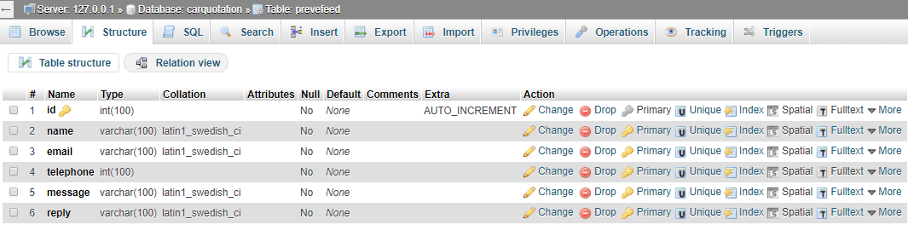

Figure 4.30 Proton Preve user feedback table in Car Quotation database

Figure 4.31 shows the Proton Saga user feedback table in Car Quotation database. Updating and deleting of user information are stored in this table.

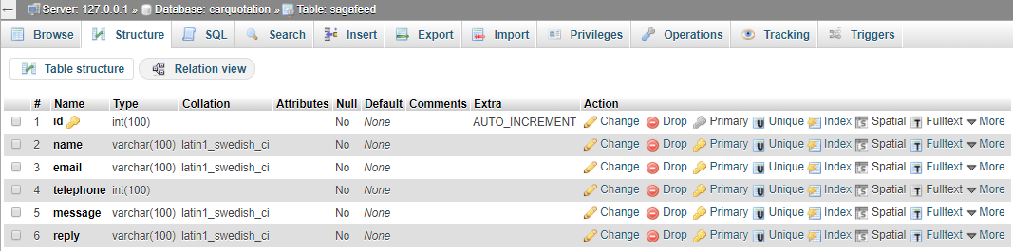

Figure 4.31 Proton Saga user feedback table in Car Quotation database

Figure 4.32 shows the Proton Suprima user feedback table in Car Quotation database. Updating and deleting of user information are stored in this table.

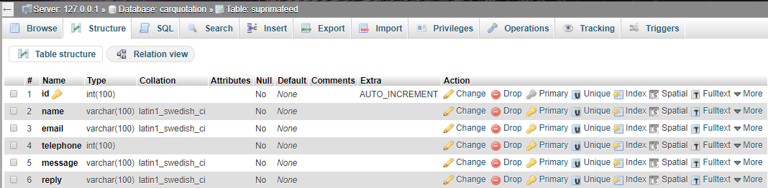

Figure 4.32 Proton Suprima user feedback table in Car Quotation database

**4.5 USER ACCEPTANCE TEST (UAT)**

For this phase, user and admin need to test the system for the user acceptance evaluation. The result shows any problem occur in the system that need to be fix and improved. The user and admin also need to fill user acceptance test form and comment to evaluate the system. The user acceptance test form will divided by two form which are user acceptance test for public user and user acceptance for admin. There are five public user and admin to test this system. Based on the user acceptance test result, all the tester are familiar and understandable in using this system. Majority of the user take short time to understand the functional requirement of the system such as fill the contact form for public user and update user feedback for admin. The test results can be refer at the appendices.

**4.5.1 User Acceptance Test for User**

Table 4.1 show user acceptance test form for user consist with acceptance requirement, critical, test result and comment. The user need to fill all the requirement for maintenance for the system.

Table 4.1 User Acceptance Test Form for User

|  |  |  |  |  |  |  |
| --- | --- | --- | --- | --- | --- | --- |
| Name | |  | | | | |
| ID | |  | | | | |
| User Categories | | User | | | | |
| Date | |  | | | | |
| Signature | |  | | | | |
| No. | Acceptance Requirement | Critical | | Test Result | | Comment |
| Yes | No | Accept | Reject |
| 1 | User can navigate using menu |  |  |  |  |  |
| 2 | User can view trending car models |  |  |  |  |  |
| 3 | User can fill contact form |  |  |  |  |  |
| 4 | User can understand properly the company information |  |  |  |  |  |
| 5 | User can select the car model based on car categories |  |  |  |  |  |
| 6 | User can go to social media website by clicking social media image button |  |  |  |  |  |
| 7 | User can fill the loan calculator form |  |  |  |  |  |
| 8 | User can view car specification |  |  |  |  |  |
| 9 | User can view approximate payments |  |  |  |  |  |
| 10 | User can select car model based on range price and location |  |  |  |  |  |

**4.5.2 User Acceptance Test for Admin**

Table 4.2 show user acceptance test form for admin consist with acceptance requirement, critical, test result and comment. The admin need to fill all the requirement for maintenance for the system.

Table 4.2 User Acceptance Test Form for Admin

|  |  |  |  |  |  |  |
| --- | --- | --- | --- | --- | --- | --- |
| Name | |  | | | | |
| ID | |  | | | | |
| User Categories | | Admin | | | | |
| Date | |  | | | | |
| Signature | |  | | | | |
| No. | Acceptance Requirement | Critical | | Test Result | | Comment |
| Yes | No | Accept | Reject |
| 1 | Admin can login to main admin page |  |  |  |  |  |
| 2 | Admin can view all the interface |  |  |  |  |  |
| 3 | Admin understand the use of add, edit and delete button |  |  |  |  |  |
| 4 | Admin can edit admin details easily |  |  |  |  |  |
| 5 | Admin can delete car specifications |  |  |  |  |  |
| 6 | Admin can reply user feedback in the system |  |  |  |  |  |
| 7 | Admin can reset the user information |  |  |  |  |  |
| 8 | Admin can reply user question completely |  |  |  |  |  |
| 9 | Admin can return to previous page by clicking return button |  |  |  |  |  |
| 10 | Admin can logout from the system |  |  |  |  |  |

**4.6 CONCLUSION**

In conclusion, chapter four discuss about the implementation and testing of the system. This chapter consists with five subtopic which are introduction of the implementation and testing of the system, implementation process, user manual, implementation of database, and user acceptance test

**CHAPTER 5**

**CONCLUSION**

**5.1 INTRODUCTION**

This chapter explain about the summarization of the proposed system. In conclusion, this proposed system are developed to solve some problems that faced by the user which support decision making for the user to select ideal cars. The user can find car models based on car categories or based on price range of the car model and branches location. The administrator can view and delete user information, adding reply comment for user question and feedback.

Online Car Quotation System may fulfil the requirement and objectives of the proposed system. To develop this system, there are some research of existing system that related to this system. For example, the comparison of existing systems, strengths and weaknesses were identified to find the requirements of the proposed system. The SDLC methodology was used to finish this system. This method contains five processes such as planning, analysis, design, implementation, and maintenance. Moreover, there are some programming languages are used to develop this system such as PHP, HTML5 and CSS. Then, MySQL is used to manage and store all data of users and admin. The conceptual design phase consists of context diagram, data flow diagram, and entity relation diagram to illustrate the concept of the system. The prototype of the Online Car Quotation System is designed to give clear image of this system.

**5.2 SYSTEM CONSTRAINT**

In order to develop this system, there are some errors occur when testing this Online Car Quotation System such as numerous quantity of pages, does not have validation for contact and Q/A form for user, and does not have validation for user feedback and question and answer(Q/A) reply form for admin.

**5.3 SYSTEM IMPROVEMENT**

Thus, there are recommended solutions to solve the problems in this system. Firstly, the system need to minimize the page and make simple design interface to improve the usability of the user to use the system. Secondly, this system also need alert validation at all form such as contact and question and answer (Q/A) form for user and user feedback and question and answer (Q/A) reply form for admin.

# **REFERENCES**

*Audi*. (n.d.). Retrieved from Audi Web site: http://www.audi.com/en.html

*Audi*. (n.d.). Retrieved from Audi Web site: https://en.wikipedia.org/wiki/Audi

*Nissan*. (n.d.). Retrieved from Nissan Web site: http://www.nissan-global.com/EN/index.html

*Nissan* . (n.d.). Retrieved from Nissan Web site: https://en.wikipedia.org/wiki/Nissan

*Proton Holdings*. (n.d.). Retrieved from Proton Holdings Web site: https://en.wikipedia.org/wiki/PROTON_Holdings

*Proton Holdings Wikipedia*. (n.d.). Retrieved from Proton Holdings Wikipedia Web site: https://en.wikipedia.org/wiki/PROTON_Holdings

*Proton-Edar*. (n.d.). Retrieved from Proton-Edar Web site: http://www.proton-edar.com.my/

*Proton-Edar* . (n.d.). Retrieved from Proton-Edar Web site: http://www.proton-edar.com.my/

*Wikipedia*. (n.d.). Retrieved from Wiki Audi: https://en.wikipedia.org/wiki/Audi

*Wikipedia*. (n.d.). Retrieved from Wiki Nissan: https://en.wikipedia.org/wiki/Nissan

*Wikipedia*. (n.d.). Retrieved from Wiki Proton Holding Web site: https://en.wikipedia.org/wiki/PROTON_Holdings

APPENDICES

# Final Report for FYP(Diploma Computer Science)

|  |
| --- |
| 1 |

ORIGINALITY REPORT

|  |  |  |  |
| --- | --- | --- | --- |
| 19%  SIMILARITY INDEX | 3%  INTERNET SOURCES | 1%  PUBLICATIONS | 18%  STUDENT PAPERS |
| PRIMARY SOURCES |  |  |  |

Submitted to Universiti Malaysia Pahang

Student Paper 14%

Submitted to Laureate Education Inc.

Student Paper 2%

Submitted to Kuala Lumpur Infrastructure 1%

University College

|  |
| --- |
| 2 |

|  |
| --- |
| 3 |

|  |
| --- |
| 4 |

Student Paper

|  |
| --- |
| 6 |

|  |
| --- |
| 5 |

en.wikipedia.org

Internet Source <1%

Submitted to California Unitec

Student Paper <1%

Submitted to Universiti Malaysia Sabah

Student Paper <1%

Submitted to Mahidol University

Student Paper <1%

Submitted to Sim University

Student Paper <1%

|  |
| --- |
| 7 |

|  |
| --- |
| 8 |

|  |
| --- |
| 9 |

gelsana.com

Internet Source <1%

|  |  |  |  |  |  |
| --- | --- | --- | --- | --- | --- |
| Thomas D. Feigenbaum. "Reuse of models and  10 the domain libraries", Elsevier BV, 2016  Publication | | | | <1% | |
| Submitted to Christchurch Polytechnic Institute  11 of Technology  Student Paper | | | | <1% | |
| Submitted to New College Pontefract  12  Student Paper | | | | <1% | |
| Submitted to Intercollege  13  Student Paper | | | | <1% | |
| Submitted to Cleary University  14  Student Paper | | | | <1% | |
| Submitted to Segi University College  15  Student Paper | | | | <1% | |
| Submitted to Fiji National University  16  Student Paper | | | | <1% | |
| Submitted to Raffles Institution  17  Student Paper | | | | <1% | |
| Submitted to University of Greenwich  18  Student Paper | | | | <1% | |
| paultan.org 19  Internet Source | | | | <1% | |
| 20 | Tizuko Morchida Kishimoto. "chapter 13 Early  Childhood Education Schools in Brazil", IGI | <1% | |

Global, 2018

Publication

|  |  |
| --- | --- |
| eprints.uthm.edu.my 21  Internet Source | <1% |
| Sape A. Miedema. "Constructing the Shields  22  Curve", Volume 7: CFD and VIV; Offshore  Geotechnics, 2011  Publication | <1% |
| www.nissan-global.com 23  Internet Source | <1% |
| www.ukessays.com 24  Internet Source | <1% |
| www.cs.joensuu.fi 25  Internet Source | <1% |
| Katrin Weller. "Frontmatter", Walter de Gruyter 26  GmbH, 2010  Publication | <1% |

Exclude quotes Off Exclude matches Off

Exclude bibliography Off